CONTACT: Jamie Hiskes/Denise Schneider FOR IMMEDIATE RELEASE
312.443.5569 or Press@GoodmanTheatre.org July 21, 2026
DIGITAL PRESS KIT: Available Here

FAMILY-FRIENDLY AND FREE, THE LIZARD Y EL SOL IS BACK IN PARKS THIS SUMMER—STARTING TOMORROW!

***SONYA MADRIGAL IS THE LIZARD, WITH OTTO ANZURES DADDA, OSIRIS “PINKY” CUEN, LUCÍA MIER Y TERÁN ROMERO & ANDREW SEPULVEDA; DIRECTED BY JAMAL HOWARD & RAQUEL TORRE THRU AUG. 9***

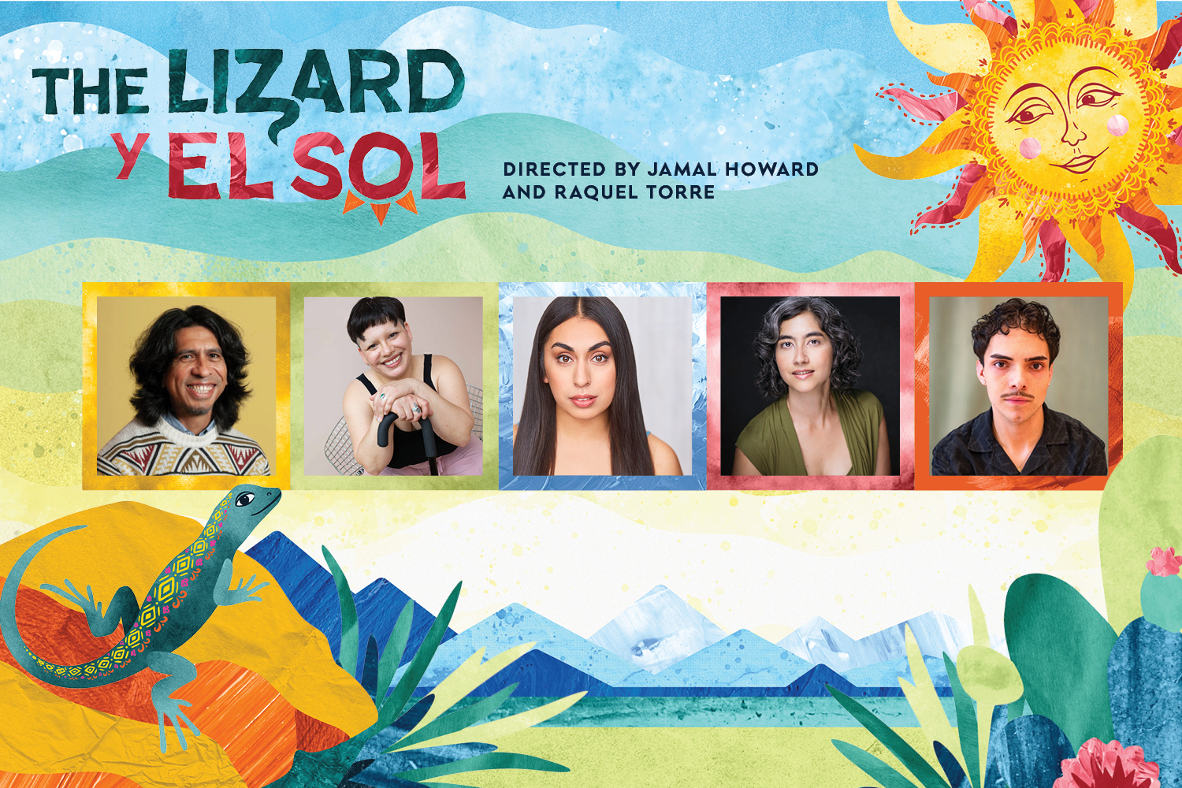
(CHICAGO, IL) The whole family can enjoy The Lizard y El Sol, returning by popular demand to 12 public spaces citywide this summer. Co-Directors Jamal Howard (Splish Splash: A Day on the Lake) and Raquel Torre (BOOK UP!) again take the reins of this beloved “Theater for the Very Young” (TVY, designed for ages 0-5) production, which drew nearly 3,000 theatergoers to Chicago parks in 2024. The cast of new faces and returning favorites includes Sonya Madrigal (Chicago Children’s Theatre’s Goodnight Moon) as the Lizard in search of the sun—joined by a cast portraying fellow animals, Osiris ”Pinky” Cuen as Carpintero (Woodpecker), Lucía Mier y Terán Romero as La Mosca (The Fly) and Andrew Sepulveda (Jaguar) with Otto Anzures Dadda (Musician/Music Director). With free performances scheduled in 11 parks and one public library, The Lizard y El Sol is presented as part of the Chicago Park District’s Night Out in the Parks series, supported by the Mayor’s Office and the Chicago Department of Cultural Affairs and Special Events (DCASE). The Lizard y El Sol appears throughout Chicago July 22 – August 9. Tickets (FREE, reservations encouraged) can be booked by calling 312.443.3800 or visiting GoodmanTheatre.org/Lizard. All performances are one hour long followed by a hands-on workshop for audiences. The Goodman is grateful for the support of the Laura Sachs Family Foundation (Major Individual Sponsor), Wintrust Commercial Bank (Community Programs Sponsor) and Kirkland & Ellis (Arts in Community Sponsor).

“Two years ago, we built this show as a beacon of hope for Chicago's young people and their caregivers, with deep love to those in our Spanish-speaking communities,” said Co-Director Raquel Torre. “The message of unlikely heroes working together to solve the crisis of a missing sun continues to resonate! As the mother of a now-five-year-old, I've seen firsthand how this story, along with its music and performances, has endured in both memory and values.”

When El Sol (the sun) mysteriously vanishes from the sky, it’s up to one brave Lizard to embark on a quest to find and bring back the light. Audiences of all ages will enjoy this enchanting retelling of a beloved Mexican folktale featuring interactive storytelling and Mexican-inspired music and dance. The Lizard y El Sol is presented primarily in Spanish but is designed to be enjoyed and understood by both Spanish and non-Spanish speakers.

“I’m thrilled to bring the joy of this story back to Chicago's children and families,” said Co-Director Jamal Howard. “The capacity for empathy starts from the day a person is born, and this show helps foster empathy in our youngest audience members as well as courage and curiosity. The story of a lizard and their animal friends searching for the missing sun inspires audiences to be active community members and encourages children to get involved directly in helping the characters solve problems. Empathy is uniquely learned by experiencing and participating in theater, the work we’re doing with productions for young audiences helps to set the foundation for a child to grow into an empathic adult.”

Theater for the Very Young (TVY) programming offers immersive theatrical experiences—produced and performed by professional artists—designed for children ages 0–5 years old to experience alongside the grown-ups in their lives. Created in 2023 by Goodman Walter Artistic Director Susan V. Booth in response to research demonstrating the profound impact the arts can have on early childhood development and long-term learning outcomes, TVY introduces Chicagoland’s youngest audiences to live theater through storytelling, music, movement and sensory-rich play produced and performed by professional artists. Over the past three years, TVY has served thousands of children and families in Chicago parks, theaters, schools and community spaces with productions of the plays Splish Splash: A Day on the Lake (2026); BOOK UP! (2025); The Lizard y El Sol (2024); and Pearl Cleage’s In My Granny’s Garden (2023).

ABOUT THE ARTISTS

Jamal Howard (Co-Director) is a Chicago-based director, choreographer and producer with a focus on creating courageous and empathetic theater. He was the 2023/2024 Goodman Theatre Michael Maggio Directing Fellow, a member of the Theatre Communication Group’s 2024 Rising Leaders of Color Cohort, Co-Artistic Director of New American Folk Theatre and an Associate Company Member with TUTA Theatre. At The Goodman, Howard co-directed Splish Splash and The Lizard y El Sol and associate directed In My Granny’s Garden. Other Goodman Theatre credits include English, A Christmas Carol, Highway Patrol and Antonio’s Song. Select directing and choreography credits include: Doctor De Soto, The Wong Kids, Splish Splash (Northwestern University); 8-Track: The Sounds of the 70s, Songs for a New World (Theo Ubique Cabaret Theatre); Jacob Marley’s Christmas Carol, A Gentleman’s Guide to Love and Murder (Backstage Breckenridge Theatre); R.E.S.P.E.C.T. (National Tour); tick, tick… Boom! (Boho Theatre); The Apple Tree (Porchlight Music Theatre); Think Fast, Jordan Chase (Filament Theatre); Corduroy, The Wiz, Magic Tree House: Showtime with Shakespeare (Emerald City Theatre); The Wiz, The Mole Hill Stories (Children’s Theatre Madison). Howard served as the Associate Artistic Director of Emerald City Theatre where he created inspiring productions that helped Chicago’s children creatively face the world. He is an alum of Loyola University Chicago. jamalhoward.com

Raquel Torre, she/her/ella (Co-Director) is a Boricua theater maker currently based in Chicago. With a background in new work development, physical performance and community-grounded spectacle, she’s been creating, directing, producing and performing in all types of theatrical productions for almost two decades. She was the 2024/2025 Goodman Theatre Michael Maggio Directing Fellow and, since 2013, has been creating original work through La Vuelta Theatre Lab (formerly Circo La Vuelta) with her partner Jean Claudio. Passionate about artistic facilitation and teaching artistry, she’s often teaching workshops and leading guided experiences, in addition to teaching a course on Latinx Theatre at Aurora University. Select Chicago directing credits include BOOK UP!, The Lizard y El Sol (Goodman); Farewell Opportunity (Filament Theatre); Aquí o Allá (Actors Gymnasium); Memorabilia (Teatro Vista); Kid Prince and Pablo (Lifeline Theatre); Back in the Day (UrbanTheater Company). Select associate/assistant director credits include: Eureka Day (Timeline Theatre); BUST, Betrayal, Inherit the Wind (Goodman); POTUS (Steppenwolf Theatre). She holds a BA in Theatre from the Universidad de Sagrado Corazón (Puerto Rico), a certificate in Movement and Devised Theatre from Cabuia Teatro (Argentina), and an MFA in Devised Performance Practice from LISPA/Columbia College Chicago (Germany/USA).

Company of The Lizard y El Sol
Presented as part of the Chicago Park District’s Night Out in the Parks Series, supported by the Mayor’s Office and the Chicago Department of Cultural Affairs and Special Events (DCASE)
Originally produced by Alliance Theatre in Atlanta, GA
Co-Directed by Jamal Howard and Raquel Torre

Sonya Madrigal...Lizard
Otto Anzures Dadda...Musician
Osiris “Pinky” Cuen...Carpintero
Lucía Mier y Terán Romero...La Mosca
Andrew Sepulveda...Jaguar

Creative Team

Scenic Designer...Ryan Emens
Costume Designer...Jazmin Aurora Medina
Music Director...Otto Anzures Dadda
Production Associate...Lauren Westfahl
Production Assistant...Mia Maccarella
Line Producer...Jared Bellot
Second Line Producer...Michael Cotey

ABOUT THE GOODMAN

Since 1925, The Goodman has been more than a stage. A theatrical home for artists and a gathering space for community, it’s where stories come to life—bold in artistry and rich in history, deeply rooted in the city it serves.

Led by Walter Artistic Director Susan V. Booth and Executive Director John Collins, The Goodman sparks conversation, connection and change through new plays, reimagined classics and large-scale musicals. With distinctions including nearly 200 world or American premieres, two Pulitzer Prizes, 22 Tony Awards and nearly 200 Joseph Jefferson Awards, The Goodman is proud to be the first theater to produce all 10 plays of August Wilson’s “American Century Cycle.” In addition, the theater frequently serves as a production partner—with national and international companies to Chicago’s Off-Loop theaters—to help amplify theatrical voices.

But The Goodman believes a more empathetic, more connected Chicago is created one story at a time, and counts as its greatest legacy the community it’s built. Generation-spanning productions and programs offer theater for a lifetime; from Theater for the Very Young (plays designed for ages 0-5) to the long-running annual A Christmas Carol, which has introduced new generations to theater over five decades, The Goodman is committed to being an asset for all of Chicago. Education and Engagement programs led by Clifford Director of Education and Engagement Jared Bellot and housed in the Alice Rapoport Center use the tools of theater to spark imagination, reflection and belonging. Each year, these programs reach thousands of people (85% from underserved communities) as well as educators, artists and lifelong learners across the city.

The Goodman stands on the unceded homelands of the Council of the Three Fires—the Ojibwe, Odawa, and Potawatomi Nations—and acknowledges the many other Nations for whom this land now called Chicago has long been home, including the Myaamia, Ho-Chunk, Menominee, Sac and Fox, Peoria, Kaskaskia, Wea, Kickapoo, and Mascouten. The Goodman is proud to partner with the Gichigamiin Indigenous Nations Museum (Gichigamiin-Museum.org) and the Center for Native Futures (CenterForNativeFutures.org)—organizations devoted to honoring Indigenous stories, preserving cultural memory, and deepening public understanding.

The Goodman was founded by William O. Goodman and his family to honor the memory of Kenneth Sawyer Goodman—a visionary playwright whose bold ideas helped shape Chicago’s early cultural renaissance. That spirit of creativity and generosity endures today. In 2000, through the commitment of Mr. Goodman’s descendants—Albert Ivar Goodman and his late mother, Edith-Marie Appleton—The Goodman opened the doors to its current home in the heart of the Loop. Marsha Cruzan is Chair of the Goodman Theatre Board of Trustees; Diane Landgren is Women’s Board President; and Kelli Garcia is president of the Scenemakers Board for Young Professionals.

—30—

