CONTACT: Jamie Hiskes/Denise Schneider FOR IMMEDIATE RELEASE
312.443.5569 or Press@GoodmanTheatre.org June 30, 2026
DIGITAL PRESS KIT: Available Here

JUST EXTENDED! DAVE MALLOY’S OCTET, RAVEN THEATRE’S ACCLAIMED FIRST MUSICAL ADDS 5 PERFORMANCES TO ITS TRANSFER TO GOODMAN THEATRE, APPEARING JULY 15 – AUGUST 2

***DIRECTOR KEIRA FROMM’S ORIGINAL CAST APPEARS IN THE PRODUCTION’S DOWNTOWN DEBUT***

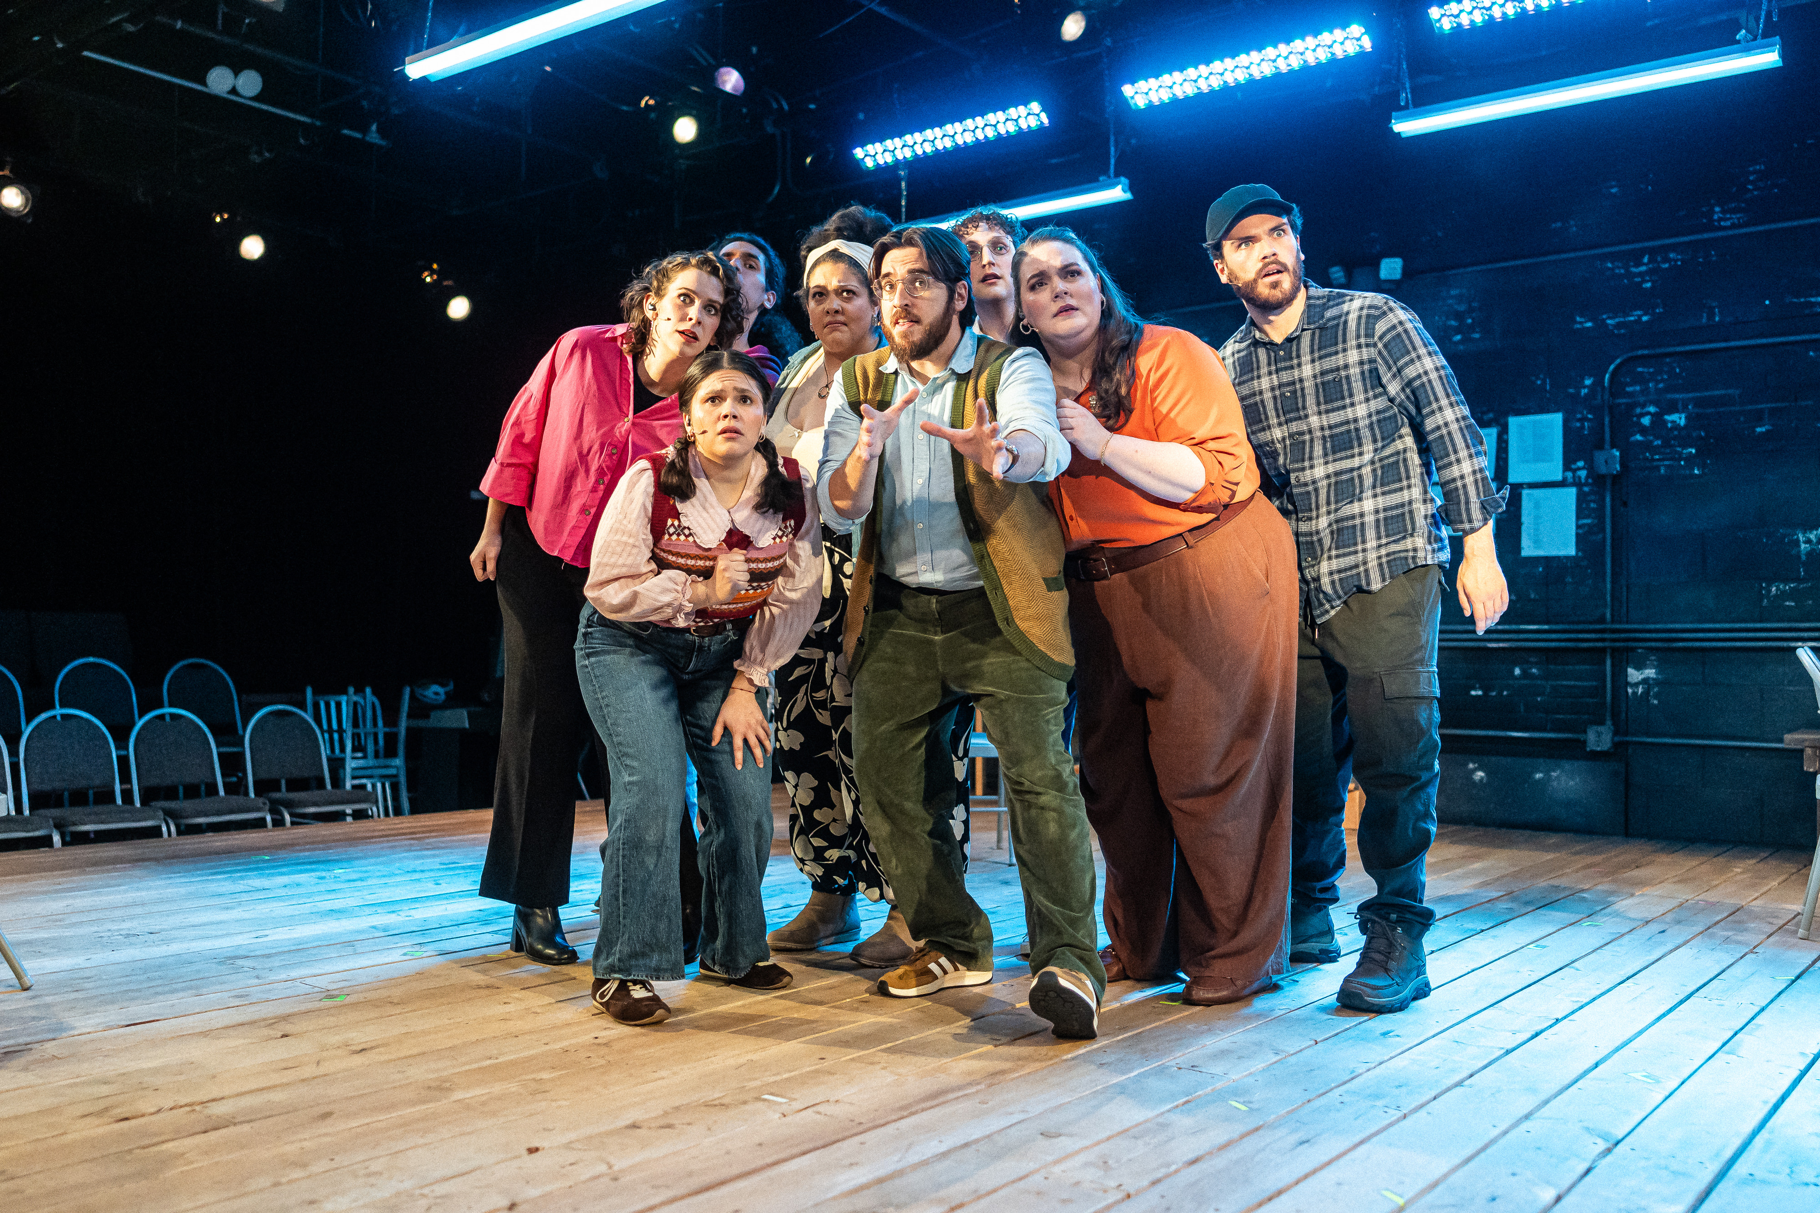
(CHICAGO, IL) Demand for “one of the most engrossing pieces of theater this year” (Chicago Tribune) extends the downtown debut of Raven Theatre’s production of Dave Malloy’s Octet. The a cappella musical is directed by Keira Fromm, Associate Director of The Goodman’s Iceboy! or The Completely Untrue Story of How Eugene O’Neill Came to Write The Iceman Cometh, with music direction by Nick Sula (Kokandy Productions’ Jekyll & Hyde) and choreography by Laura Savage (The Lord of the Rings International Tour). The Goodman’s presentation of the Raven Theatre production features Raven’s original cast—including Neala Barron (Porchlight Theatre’s Fun Home), Elliot Esquivel (Lookingglass Theatre’s White Rooster), Joryhebel Ginorio (Theo Ubique’s The Secret Garden), Jordan Golding (A Christmas Carol), Teressa LaGamba (Paramount Theatre’s Waitress), Ryder Dean McDaniel (Court Theatre’s Taming of the Shrew), Sam Shankman (Court Theatre’s Falsettos) and Grace Steckler (Writers Theatre’s As You Like It).

Raven Theatre's production of Dave Malloy’s Octet transfers to The Goodman this summer, appearing in the 400-seat flexible Owen Theatre July 15-August 2—including just-added performances on July 29 at 7:30pm, July 30 at 2pm, August 1 at 2pm and August 2 at 2pm and 7:30pm. For tickets ($39 -$94, subject to change), call 312.443.3800 or purchase online at GoodmanTheatre.org/Octet. This project is partially supported by a grant from the City of Chicago Department of Cultural Affairs and Special Events (DCASE). This programming is also supported in part by a grant from the Illinois Arts Council.

"Octet has been a rare and remarkable experience here at the Raven, and we are so very excited to partner with The Goodman in creating a downtown extension for this production," said Raven Theatre Executive Artistic Director Jonathan Berry. "At its heart, Raven is always looking to build community, and this is a fantastic opportunity to share this production that we’re so proud of with a wider audience.”

In an anonymous meeting room on the North Side of Chicago, a group of people—always eight—gathers to sing. Best known for the Broadway hit Natasha, Pierre, & The Great Comet Of 1812, Dave Malloy’s Octet uses chamber-inspired a cappella music to explore the total impact of life online. Hailed by The New York Times as “the most original and topical musical of the year” for its 2019 Off-Broadway premiere, this inventive and acutely relevant piece reflects the perils of the digital age.

ABOUT THE ARTISTS

Dave Malloy (Playwright) is a composer/writer/performer/orchestrator. He has written 13 musicals, including Octet, a chamber choir musical about internet addiction; Natasha, Pierre & The Great Comet of 1812, an electropop opera based on a slice of Tolstoy’s War & Peace (12 Tony nominations, including Best Musical, Score, Book, and Orchestrations); Ghost Quartet, a song cycle about love, death, and whiskey; Preludes, a musical fantasia set in the hypnotized mind of Sergei Rachmaninoff; Little Bunny Foo Foo, a forest entertainment for small people; Three Pianos, a drunken romp through Schubert’s “Winterreise”; Black Wizard/Blue Wizard, an escapist RPG fantasy; Beowulf—A Thousand Years of Baggage, an anti-academia rock opera; Beardo, a reinterpretation of the Rasputin myth; Sandwich, a musical about killing animals; and Clown Bible, Genesis to Revelation told through clowns. He has won two Obie Awards, a Smithsonian Ingenuity Award, a Theater World Award, the Richard Rodgers Award, an ASCAP New Horizons Award, and a Jonathan Larson Grant, and has been a MacDowell fellow and Composer-in-Residence at Ars Nova and the Signature Theatre. Future projects include an adaptation of Moby-Dick. He lives in Brooklyn. Davemalloy.com

Keira Fromm (Director) is a Chicago-based freelance director. Chicago credits include Iceboy! Or The Completely Untrue Story of How Eugene O’Neill Came to Write The Iceman Cometh (Goodman Theatre); Octet (Raven Theatre); The Brightest Thing in the World, Bull in a China Shop, Significant Other, Bright Half Life and A Kid Like Jake (About Face Theatre); The Last Match (Writers Theatre); Top Girls, hang (Remy Bumppo); The How and the Why (TimeLine Theatre). Regional: We Had a World (Huntington Theatre); The Liar, The Moors and A Doll’s House (American Players Theatre); Who’s Afraid of Virginia Woolf (Milwaukee Chamber Theatre). MFA DePaul University. Member of SDC, the professional directors union. keirafromm.com

Nick Sula (Music Director) is an award-winning music director and pianist. Recent productions include music direction with Kokandy Productions on the Jeff Award-winning productions of Jekyll & Hyde (Jeff Award for Outstanding Music Direction), Into the Woods (Jeff Awards for Outstanding Music Direction and Orchestration), Sweeney Todd (Jeff Award for Outstanding Music Direction), and the Chicago Musical Theatre Festival. Other Chicago theatre music direction credits include: Anything Goes (Jeff nomination) with Porchlight Music Theatre; Dave Malloy’s Ghost Quartet (Jeff nomination), Mary Rose, Nevermore, Amour, and Coraline with Black Button Eyes Productions; Myths & Hymns, The Glorious Ones (Jeff nomination), Hello Again, La Cage aux Folles, and Pippin with BoHo Theatre. As a professor of musical theatre, he serves as a music director, instructor and vocal coach at the Chicago College of Performing Arts at Roosevelt University.

Laura Savage (Choreographer) most recently was the Associate Choreographer for The Lord of The Rings international tour. Past choreography work includes: Cruel Intentions (Kokandy Productions; Jeff nominated), Rock of Ages (Mercury Theatre) Rent (Porchlight Music Theatre), Zorro and Shrek (Music Theatre Works), Shrek (Drury Lane), Elephant and Piggie (Marriott Theatre), and many productions for BAM Theatre. Laura has associate choreographed and dance captained at: Marriott Theatre, Paramount Theatre, and Drury Lane Theatre. She is a Jeff nominated actress and has performed in over 40 productions across the Chicagoland area. Laura also choreographed for and appeared on Fox’s hit show EMPIRE. @lauramsavage www.laura-savage.com

The Goodman Presents
Raven Theatre’s Production of
Dave Malloy's
Octet
Music, Lyrics, Book and Vocal Arrangements by Dave Malloy
Directed by Keira Fromm
Music Directed by Nick Sula
Choreographed by Laura Savage

Neala Barron...Jessica
Elliot Esquivel...Toby
Joryhebel Ginorio...Velma
Jordan Golding...Marvin
Teressa LaGamba...Paula
Ryder Dean McDaniel...Ed
Sam Shankman...Henry
Grace Steckler…Karly

Understudies include Diana Marilyn Alvarez (Paula), Eric Amundson (Henry), Danny Andrew Bennett (Ed), Caitlyn Cerza (Karly), Joe Giovannetti (Marvin), Andrew Lund (Toby), Mizha Lee Overn (Velma) and Dani Pike (Jessica).

Creative Team

Scenic Designer...Milo Bue
Lighting Designer...Maximo Grano de Oro
Co-Sound Designer...Christopher Kriz
Co-Sound Designer...Hannah Kwak
Costume Designer...Maegan Pate
Props Coordinator...Paloma Locsin
Master Electrician...Ruby Lowe
Associate Scenic Designer...Wynn Lee
Assistant Director and Dance Captain...Mads Wren
Music Captain...Joe Giovannetti
Assistant Master Electrician...Emmitt Socey
Production Manager...Lucy Whipp

Casting and Dramaturgy by Catherine Miller. JC Widman and Faith Locke are the Stage Managers.

ABOUT RAVEN THEATRE COMPANY

Raven Theatre (6157 N. Clark) tells stories of today and the past that connect us to our cultural landscape. Through its plays, as well as its educational programming, Raven is committed to serving our communities’ needs through the arts. Raven Theatre Company is funded in part by The Gaylord and Dorothy Donnelley Foundation, JCCC Foundation, Paul M. Angell Foundation, Polk Bros Foundation, S&C Electric Company Fund and The Shubert Foundation. For more information, visit www.raventheatre.com.

ABOUT THE GOODMAN

Since 1925, The Goodman has been more than a stage. A theatrical home for artists and a gathering space for community, it’s where stories come to life—bold in artistry and rich in history, deeply rooted in the city it serves.

Led by Walter Artistic Director Susan V. Booth and Executive Director John Collins, The Goodman sparks conversation, connection and change through new plays, reimagined classics and large-scale musicals. With distinctions including nearly 200 world or American premieres, two Pulitzer Prizes, 22 Tony Awards and nearly 200 Joseph Jefferson Awards, The Goodman is proud to be the first theater to produce all 10 plays of August Wilson’s “American Century Cycle.” In addition, the theater frequently serves as a production partner—with national and international companies to Chicago’s Off-Loop theaters—to help amplify theatrical voices.

But The Goodman believes a more empathetic, more connected Chicago is created one story at a time, and counts as its greatest legacy the community it’s built. Generation-spanning productions and programs offer theater for a lifetime; from Theater for the Very Young (plays designed for ages 0-5) to the long-running annual A Christmas Carol, which has introduced new generations to theater over five decades, The Goodman is committed to being an asset for all of Chicago. Education and Engagement programs led by Clifford Director of Education and Engagement Jared Bellot and housed in the Alice Rapoport Center use the tools of theater to spark imagination, reflection and belonging. Each year, these programs reach thousands of people (85% from underserved communities) as well as educators, artists and lifelong learners across the city.

The Goodman stands on the unceded homelands of the Council of the Three Fires—the Ojibwe, Odawa, and Potawatomi Nations—and acknowledges the many other Nations for whom this land now called Chicago has long been home, including the Myaamia, Ho-Chunk, Menominee, Sac and Fox, Peoria, Kaskaskia, Wea, Kickapoo, and Mascouten. The Goodman is proud to partner with the Gichigamiin Indigenous Nations Museum (Gichigamiin-Museum.org) and the Center for Native Futures (CenterForNativeFutures.org)—organizations devoted to honoring Indigenous stories, preserving cultural memory, and deepening public understanding.

The Goodman was founded by William O. Goodman and his family to honor the memory of Kenneth Sawyer Goodman—a visionary playwright whose bold ideas helped shape Chicago’s early cultural renaissance. That spirit of creativity and generosity endures today. In 2000, through the commitment of Mr. Goodman’s descendants—Albert Ivar Goodman and his late mother, Edith-Marie Appleton—The Goodman opened the doors to its current home in the heart of the Loop. Marsha Cruzan is Chair of the Goodman Theatre Board of Trustees; Diane Landgren is Women’s Board President; and Kelli Garcia is president of the Scenemakers Board for Young Professionals.

—30—

