CONTACT: Denise Schneider/Jamie Hiskes FOR IMMEDIATE RELEASE
312.443.5151 or Press@GoodmanTheatre.org May 28, 2026
IMAGES: Rehearsal Photos Available Here

A PEEK INTO REHEARSALS OF THE NEW MUSICAL ICEBOY! WITH MEGAN MULLALLY AND NICK OFFERMAN,
GREY HENSON, CEDRIC YARBROUGH, SARAH STILES, ALEX GOODRICH & MORE

***WITH MUSIC BY MARK HOLLMANN, LYRICS BY HOLLMANN AND JAY REISS, BOOK BY ERIN QUINN PURCELL AND REISS, ICEBOY! STARTS JUNE 20—MARC BRUNI DIRECTS, JOANN M. HUNTER CHOREOGRAPHS***

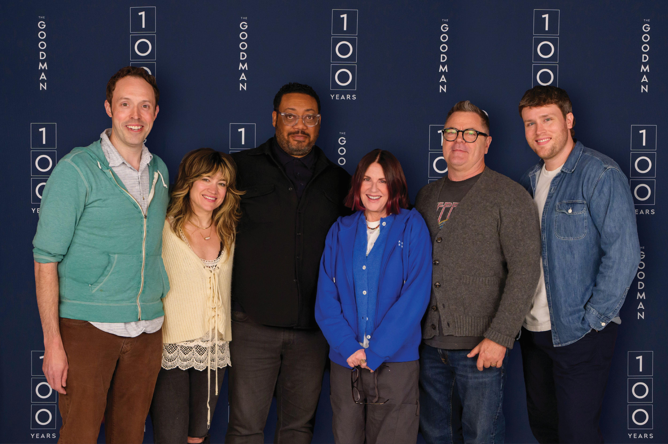
(CHICAGO, IL) Rehearsals are underway for the musical event of the summer: Iceboy! Or, The Completely Untrue Story of How Eugene O‘Neill Came to Write The Iceman Cometh. With music by Mark Hollmann, lyrics by Mark Hollmann and Jay Reiss, and book by Erin Quinn Purcell and Jay Reiss, the world-premiere production is at once the capstone to The Goodman’s Centennial Season and its latest in a longtime history of premiering new large-scale American musicals. Marc Bruni (Broadway’s The Great Gatsby and Beautiful: The Carole King Musical) directs with choreography by JoAnn M. Hunter (The Penelopiad). Iceboy! Or The Completely Untrue Story of How Eugene O’Neill Came to Write The Iceman Cometh appears in the 856-seat Albert Theatre June 20 – July 26. Opening night is June 29. For tickets ($44 - $189, subject to change) call 312.443.3800 or purchase online at GoodmanTheatre.org/Iceboy. The Goodman is grateful for the support of its Iceboy! sponsors: Edgerton Foundation (New Play Award), Mayer Brown (Lead Corporate Sponsor) and Athletico (Physical Therapy Provider).

“It began as a scrappy little play called Hooray for Iceboy, which Jay and I co-wrote with the adobe theatre company in New York City. Audiences responded right away, which encouraged us to keep going. In 2012, we brought Mark on board—and here we are today,” said playwright Erin Quinn Purcell. "As someone from Illinois, working at The Goodman feels like a theatrical mecca. And there’s something exciting about creating Iceboy! in a place with such a rich history with Eugene O’Neill’s work, for audiences who are so smart and savvy. We hope we live up to that—in a fun way.”

Broadway’s brightest star of 1938, Vera Vimm (Megan Mullally), is at the top of her game. But when she adopts a 40,000-year-old Neanderthal discovered frozen in the Arctic, the spotlight begins to shift. As Iceboy (Grey Henson) thaws, he unexpectedly becomes a theatrical sensation, inspiring the “father of the American drama” Eugene O’Neill (Nick Offerman) and challenging his legendary mother for center stage. It’s All About Eve...if only Eve was a caveman.

“The late 1930s were such a strange time—people would go to the theater at 8:30pm, be out by 11, and then head to a supper club...on a weeknight. When did they sleep? It’s fun to cherry-pick history to suit the story,” said Jay Reiss, the creator of the Tony Award-winning musical The 25th Annual Putnam County Spelling Bee (with Rachel Sheinkin and William Finn). "Iceboy! is still evolving, but together we hope to create something unique and special that we can’t wait for audiences to experience.”

The cast stars Emmy Award winners Megan Mullally (NBC’s Will & Grace) and Nick Offerman (NBC’s Parks and Recreation), Tony Award nominee Grey Henson (Broadway’s Mean Girls), Cedric Yarbrough (Comedy Central’s Reno 911!), Tony Award nominee Sarah Stiles (Broadway’s Tootsie) and Alex Goodrich (Marriott Theatre’s Hero: The Musical), together with Donterrio (Nightbirds), Melanie Brezill (A Christmas Carol), Will Koski (Paramount Theatre’s Into the Woods), Linda Mugleston (Broadway’s The Music Man), Shawn Pfautsch (The Matchbox Magic Flute), Andrea San Miguel (The Penelopiad), Will Lidke (Theo Ubique’s Hedwig and the Angry Inch), Leah Morrow (Marriott Theatre’s Heartbreak Hotel) and Jeff Parker (Betrayal). Casting note: Shawn Pfautsch will appear as Eugene O’Neill, the role typically played by Nick Offerman, at the June 20, 21, 23 and 24 preview performances.

“Bringing this new musical to The Goodman during its Centennial Season is especially meaningful for me. I grew up in downstate Illinois and spent my early adulthood in Chicago working in storefront theaters, dreaming of one day working at The Goodman. I learned so much by seeing world premieres here—so it’s an honor to now have one of my own musicals premiere on this stage,” said Mark Hollmann, Tony Award-winning creator of the musical Urinetown (with Greg Kotis).

ABOUT THE ARTISTS

Megan Mullally (Vera Vimm) created the role of Karen Walker on Will & Grace, a role for which she went on to win two Emmys and four SAG awards. On Broadway, she has starred in How to Succeed in Business, Young Frankenstein, and Grease, in addition to Guys and Dolls at Carnegie Hall, opposite Nathan Lane. On-screen credits include Chasing Summer, Dicks: The Musical, The Righteous Gemstones, Party Down, Reservation Dogs, Bobs’s Burgers, Childrens Hospital, Parks and Recreation, and the upcoming film Goodbye Girl. She tours worldwide with her band Nancy And Beth as creator, lead singer and choreographer.

Nick Offerman (Eugene O’Neill) is an actor, author, humorist and woodworker whose credits include the Emmy award-winning role of Bill in The Last of Us (HBO), Ron Swanson on NBC’s Parks and Recreation, Forest in Devs (FX), and Jinx in Margo’s Got Money Troubles (Apple). Stage credits include the role of Ignatius J. Reilly in A Confederacy of Dunces at the Huntington Theatre, Ulysses in Sharr White’s Annapurna, opposite Megan Mullally as Emma at The Odyssey/Evidence Room in LA and The New Group Off-Broadway, Adding Machine at The Minetta Lane (Off-Broadway) and many Chicago credits at Defiant Theatre (Founding Member), Steppenwolf, A Red Orchid, Wisdom Bridge, Chicago Shakespeare and, of course, his 1994 Goodman debut as The Keeper/Fight Captain in Richard II. Recent screen projects include Death by Lightning (Netflix), Sovereign, Voicemails For Isabel (Netflix), Civil War (written and directed by Alex Garland), The Pout Pout Fish, Origin (written and directed by Ava DuVernay), Mission: Impossible - The Final Reckoning, Fargo (FX), Smurfs, The Umbrella Academy (Netflix), and NBC’s Making It (co-host and executive producer). He is the voice of Beef Tobin in the FOX animated series The Great North and audiobook narrator for Wendell Berry’s latest, The Need to Be Whole.

Grey Henson (Iceboy) was most recently seen as Bigfoot in Bigfoot! The Musical Off-Broadway, for which he earned a Drama League Award nomination. Broadway credits include Buddy in the 2024 revival of Elf The Musical (Drama Desk Award nomination), Damian in Mean Girls The Musical (Tony and Drama Desk nominations), Storyteller 2 in Shucked, and Elder McKinley in The Book of Mormon, a role that he originated on the first national tour. Other credits include Michael in tick, tick… BOOM! at the Kennedy Center and Tate in the Netflix series Girls5Eva. Carnegie Mellon University Drama.

Cedric Yarbrough (Floyd) is a multi-hyphenate performer recently seen in Clint Eastwood's latest film Juror #2, the Netflix film Unfrosted and the AMC series Lucky Hank. He starred in ABC's Speechless, The Goldbergs, CBS’ Carol's Second Act, Curb Your Enthusiasm and Key and Peele. The Minnesotan began his career with 8 seasons of Comedy Central’s hit Reno 911! as “Deputy S. Jones.” He was seen in The 40-Year-Old Virgin, The House, The Boss and Black Dynamite. Yarbrough is also a talented voice-over artist whose work includes Bob’s Burgers, Family Guy, Bojack Horseman, Kung Fu Panda 4 and the Peabody Award-winning The Boondocks.

Sarah Stiles (Lambert) is a two-time Tony Award-nominated actor for Tootsie and Hand to God. Other Broadway: On a Clear Day You Can See Forever, Avenue Q and The 25th Annual Putnam County Spelling Bee. Off-Broadway: The Imaginary Invalid (Red Bull); Into the Woods (Delacorte); Vanities (Second Stage). Stiles stars opposite Kevin James in the Netflix comedy The Crew, is Gladys in the critically acclaimed EPIX Original Series Get Shorty and Bonnie on Showtime’s Billions. She voices Spinel in Steven Universe (Cartoon Network) and Mimzy in Hazbin Hotel (Amazon). Film: Transformers: Rise of the Beast, This Will Never Work, Unsane.

Alex Goodrich (Frankenstein) is thawed to make his Goodman Theatre debut! Chicago credits include several shows at Court Theater, Marriott Theater, Chicago Shakespeare, Northlight, Royal George, Drury Lane and Writers Theater. He’s been nominated several times for a Jeff award and won once. TV credits include Chicago Fire and Shining Girls on Apple TV+.

Mark Hollmann (Music and Lyrics) won the Tony Award®, the Obie Award, and the National Broadway Theatre Award for his music and lyrics to Urinetown The Musical, which went from the 1999 New York International Fringe Festival (FringeNYC) to receive 10 Tony Award® nominations and 11 Drama Desk Award nominations and win the Outer Critics Circle, the Drama League and the Lucille Lortel Awards for best musical. His other shows as composer/lyricist include The Sting (Paper Mill Playhouse), ZM (Village Theatre Beta Series), Yeast Nation (FringeNYC), Bigfoot and Other Lost Souls (Perseverance Theatre), and The Girl, The Grouch and The Goat (University of Kansas Theatre and Chance Theatre). For TV, he has written songs for the Disney Channel’s Johnny and the Sprites. He received his A.B. in music from the University of Chicago, where he won the Louis J. Sudler Award in the Performing and Creative Arts. He has taught at Princeton University, Columbia College Chicago and the Dramatists Guild Institute. He is a member of the American Society of Composers, Authors, and Publishers (ASCAP) and the Dramatists Guild of America, and has served on the council of the Dramatists Guild as well as on the Tony Award® Nominating Committee.

Jay Reiss (Book and Lyrics) is one of the creators of The 25th Annual Putnam County Spelling Bee, which won two Tony awards, and made his Broadway acting debut as the Bee’s word pronouncer, Vice Principal Douglas Panch. He co-wrote the screenplay for The Oranges, which premiered at the Toronto Film Festival, and starred Hugh Laurie, Allison Janney, Oliver Platt and Catherine Keener. He wrote the documentary New Wave: Dare To Be Different, about legendary NY radio Station WLIR. It premiered at the Tribeca Film Festival and later on Showtime. Reiss is a graduate of The Juilliard School’s playwriting program.

Native Illinoisan Erin Quinn Purcell (Book) has been a mainstay in New York’s downtown theater scene for more than 30 years. She was one of the founding members of the critically acclaimed adobe theatre company, and participated as an actor, writer and/or director in countless productions. Writing credits include Duet! A Romantic Fable (Broadway Play Publishing), The Fiona Apple Kwanzaa Explosion (PSNBC), the musical A Fish Story (Jonathan Larson Foundation award) and the Russ Meyer inspired Go-Go Kitty, Go! (Outstanding Play, 2005 New York Fringe Festival).

Marc Bruni (Director) helmed The Great Gatsby (Broadway, West End, Korea) as well as the Tony, Grammy, and Olivier Award-winning Beautiful: The Carole King Musical (Broadway, West End, US and UK Tours, and in Australia- Helpmann Award Best Director). Other credits include Billie Jean (Chicago Shakes), The Sound of Music (Chicago Lyric), Bull Durham (Paper Mill), A Little Night Music (Geffen Hall), Trevor: The Musical (Stage 42, Disney+), Bye Bye Birdie, Guys and Dolls, The Music Man, How to Succeed in Business..., 50 Years of Broadway (Kennedy Center), and Hey, Look Me Over!, Paint Your Wagon, Pipe Dream and Fanny (City Center Encores!), Tale of Despereaux (Old Globe, Berkeley), Love All (La Jolla), The Explorers Club (MTC), Ordinary Days (Roundabout), 9 shows for the St. Louis MUNY.

Company of Iceboy! Or The Completely Untrue Story of How Eugene O’Neill Came to Write
The Iceman Cometh
Music By Mark Hollmann
Lyrics by Mark Hollmann and Jay Reiss
Book by Erin Quinn Purcell and Jay Reiss
Directed by Marc Bruni
Choreographed by JoAnn M. Hunter

Alex Goodrich...Frankenstein
Grey Henson... Iceboy
Megan Mullally...Vera Vimm
Nick Offerman...Eugene O’Neill
Sarah Stiles...Lambert
Cedric Yarbrough...Floyd Richards
Donterrio, Melanie Brezill, Will Koski, Linda Mugleston, Shawn Pfautsch, Andrea San Miguel…Ensemble
Will Lidke, Leah Morrow, Jeff Parker…Swing

Creative Team

Set Designer...Paul Tate dePoo III
Lighting Designer...Jen Schriever
Costume Designer...Linda Cho
Wig & Hair Designer...Charles “Chuck” LaPointe
Sound Designer...Connor Wang
Music Director and Conductor/Pianist...Vadim Feichtner
Orchestrations...Bruce Coughlin
Music Preparation...John Blane
Voice & Dialect...Michelle Lopez-Rios
Violence & Intimacy...Chels Morgan
Associate Director...Keira Fromm
Associate Sound Designer...Emily Hayman
Associate Choreographer...Liz Ramos
Associate Costume Designer...Patrick Bevilacqua
Associate Wig & Hair Designer/Makeup Designer...Rachael Geier
Associate Lighting Designer...Paul Vaillancourt
Associate Set Designer...Kaitlyn Peterson
Assistant Director...Lo Williams
Assistant Music Director and Cover Conductor...Jo Ann Daugherty
Music Assistant...Jordan Klein
Assistant Sound Designer...Emily Lynch
Assistant Lighting Designer...Emma Berry
Script and Production Assistant...Molly Rosen
Production Assistant...Tuesday Thacker
Line Producer...Malkia Stampley
Second Line Producer...Adam Belcuore

Casting by Lauren Port, CSA and NY Casting by Jim Carnahan, CSA and Jason Thinger, CSA. Jennifer Gregory is the Production Stage Manager. Nikki Blue and Beth Koehler are the Stage Managers.

ENHANCED AND ACCESSIBLE PERFORMANCES
Visit GoodmanTheatre.org/Access for more information about The Goodman’s accessibility efforts.

ASL-Interpreted...July 17 at 7:30pm – An ASL interpreter signs the action/text as played.
Audio-Described...July 18 at 2pm; Touch Tour; 12:30pm – Action audibly enhanced via headset.
Spanish-Subtitled...July 18 at 7:30pm – Spanish-translated dialogue via LED sign.
Open-Captioned...Jul 19 at 2pm – LED sign presents dialogue in sync with the performance.

ABOUT THE GOODMAN

Since 1925, The Goodman has been more than a stage. A theatrical home for artists and a gathering space for community, it’s where stories come to life—bold in artistry and rich in history, deeply rooted in the city it serves.

Led by Walter Artistic Director Susan V. Booth and Executive Director John Collins, The Goodman sparks conversation, connection and change through new plays, reimagined classics and large-scale musicals. With distinctions including nearly 200 world or American premieres, two Pulitzer Prizes, 22 Tony Awards and nearly 200 Joseph Jefferson Awards, The Goodman is proud to be the first theater to produce all 10 plays of August Wilson’s “American Century Cycle.” In addition, the theater frequently serves as a production partner—with national and international companies to Chicago’s Off-Loop theaters—to help amplify theatrical voices.

But The Goodman believes a more empathetic, more connected Chicago is created one story at a time, and counts as its greatest legacy the community it’s built. Generation-spanning productions and programs offer theater for a lifetime; from Theater for the Very Young (plays designed for ages 0-5) to the long-running annual A Christmas Carol, which has introduced new generations to theater over five decades, The Goodman is committed to being an asset for all of Chicago. Education and Engagement programs led by Clifford Director of Education and Engagement Jared Bellot and housed in the Alice Rapoport Center use the tools of theater to spark imagination, reflection and belonging. Each year, these programs reach thousands of people (85% from underserved communities) as well as educators, artists and lifelong learners across the city.

The Goodman stands on the unceded homelands of the Council of the Three Fires—the Ojibwe, Odawa, and Potawatomi Nations—and acknowledges the many other Nations for whom this land now called Chicago has long been home, including the Myaamia, Ho-Chunk, Menominee, Sac and Fox, Peoria, Kaskaskia, Wea, Kickapoo, and Mascouten. The Goodman is proud to partner with the Gichigamiin Indigenous Nations Museum (Gichigamiin-Museum.org) and the Center for Native Futures (CenterForNativeFutures.org)—organizations devoted to honoring Indigenous stories, preserving cultural memory, and deepening public understanding.

The Goodman was founded by William O. Goodman and his family to honor the memory of Kenneth Sawyer Goodman—a visionary playwright whose bold ideas helped shape Chicago’s early cultural renaissance. That spirit of creativity and generosity endures today. In 2000, through the commitment of Mr. Goodman’s descendants—Albert Ivar Goodman and his late mother, Edith-Marie Appleton—The Goodman opened the doors to its current home in the heart of the Loop. Marsha Cruzan is Chair of the Goodman Theatre Board of Trustees; Diane Landgren is Women’s Board President; and Kelli Garcia is president of the Scenemakers Board for Young Professionals.

—30—

