CONTACT: Jamie Hiskes/Denise Schneider FOR IMMEDIATE RELEASE
312.443.5569 or Press@GoodmanTheatre.org May 6, 2026
PHOTOS/VIDEO: Available Here

A FIRST LOOK AT YORK WALKER’S SUPERNATURAL THRILLER COVENANT, NOW ON STAGE THRU MAY 31

***PHOTOS AND VIDEO OF DIRECTOR MALKIA STAMPLEY’S CHICAGO-PREMIERE PRODUCTION
ARE NOW AVAILABLE***

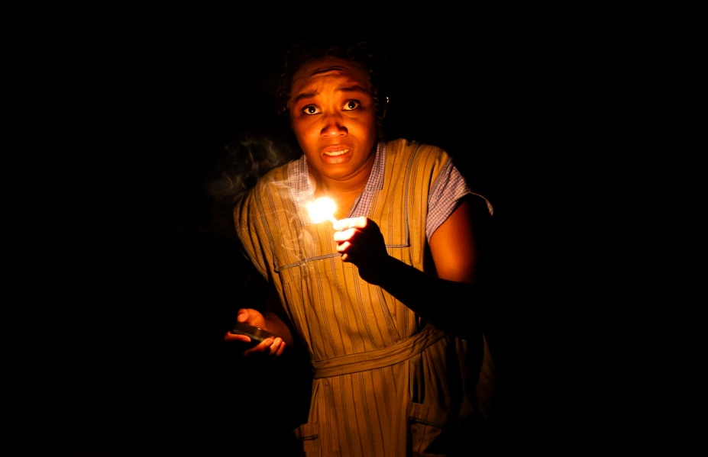
(CHICAGO, IL) Secrets come to light, faith is tested and myth becomes reality in Chicago native York Walker’s Covenant—a Southern Gothic supernatural thriller with a “scorching end-of-days” tone (New York Times) that garnered critical acclaim and a New York Times Critics Pick during its 2023 Off-Broadway debut with Roundabout Theatre Company. BOLD Artistic Producer Malkia Stampley directs the hometown premiere—the final Centennial 25/56 Season production in The Goodman’s intimate Owen Theatre. Get a peek at designer Ryan Emens’ dynamic, illusion-laced set and the all-Chicago cast now on stage, including Debo Balogun (graveyard shift), Ashli René Funches (A Red Orchid Theatre’s IS GOD IS), Jaeda LaVonne (Chicago Shakespeare Theatre’s Twelfth Night), Felicia Oduh (The Nacirema Society) and Anji White (Fat Ham). Now in previews, Covenant opens May 11 and appears through May 31 in the 380-seat flexible Owen Theatre. For tickets ($24 - $64, subject to change), visit the Box Office (170 N. Dearborn), call 312.443.3800 or purchase online at GoodmanTheatre.org/Covenant. The Goodman is grateful for the support of BOLD Ventures (Production Sponsor), Tabet, DiVito & Rothstein (Corporate Supporter) and The Elizabeth Morse Charitable Trust (Lead Sponsor of IDEAA Programming).

Expect one devilish twist after another in this “undeniably spooky (and) absolutely enjoyable” (TheaterMania) mythic and suspenseful new play. Johnny “Honeycomb” James (Debo Balogun) left his small Georgia town a struggling guitarist—and returned a blues star, to the surprise of sisters Violet (Felicia Oduh) and Avery (Jaeda LaVonne), their mother (Anji White) and their best friend Ruthie (Ashli René Funches). As rumors of a darker deal abound, it becomes clear that he’s not the only one with a secret…or seeking salvation. This tense thriller explores the power of belief and the thin line between rumor and truth.

SPECIAL EVENTS

CONTEXT: Covenant Behind the Curtain
May 8 | 6pm
Tickets: $10 (event only)

This CONTEXT event dives into the creative process behind Covenant—exploring the line between superstition and belief and the historical forces that shaped this haunting story. The pre-show experience in the Alice Center will include refreshments and a beverage.

Hidden GEMS: The Goodman Vendor Fair
May 23 | 12:30-7:30pm
Open to the public

Now in its fourth year, the Hidden GEMS (Goodman Entrepreneur Market) Pop-Up showcases and celebrates the work of Black creators and brands across various fields, including fashion, art, music, literature, cuisine and more. Local makers from Chicagoland will have their work available to experience in The Goodman’s lobby before and after the matinee performance and before the evening performance of Covenant. Vendors announced at a later date.

ABOUT THE ARTISTS

York Walker is an award-winning playwright and screenwriter from Chicago. He is the inaugural recipient of both the Vineyard Theatre's Colman Domingo Award and the John Singleton Screenwriting Award. His work includes Holcomb & Hart (Victory Garden's New Plays For A New Year Festival), The Séance (Winner of the John Singleton Screenwriting Competition, 48 Hours... in Harlem), Covenant (Colman Domingo Award, Roundabout Underground, South Coast Repertory's Pacific Playwrights Festival, Fire This Time Festival) and Soul Records (workshops with Manhattan Theatre Club, the Vineyard Theatre and Roundabout Theatre Company). York is currently developing new works with Roundabout Theatre Company, South Coast Repertory Theatre, The Geffen Playhouse and Goodman Theatre. His contributions extend to the realm of television, having served as Story Editor and Staff Writer for two seasons on Dick Wolf's hit series, FBI. York is a graduate of the MFA Acting program from the American Conservatory Theatre.

Malkia Stampley is a twice Jeff-nominated director from Milwaukee and The Goodman’s BOLD Artistic Producer. Her Goodman Theatre directing credits include A Christmas Carol, Primary Trust, In My Granny’s Garden and New Stages Festival’s Cephianne’s Reflection and This Part of His Life Blooms. Select directing credits: No Such Thing (Rivendell); Girls on Sand (Northern Sky); Nina Simone: Four Women (Milwaukee Rep); The October Storm (Raven); Boulevard of Bold Dreams (TimeLine); STEW (Shattered Globe); Black Nativity (Black Arts MKE); The Gift of the Magi (American Players); Five Guys Named Moe (Skylight Music); Lady Day at Emerson’s Bar and Grille (Farmers Alley); Exit Strategy (Northwestern).

Full Company of Covenant (in alphabetical order)
By York Walker
Directed by Malkia Stampley
Debo Balogun...Johnny James
Ashli René Funches...Ruthie
Jaeda LaVonne...Avery
Felicia Oduh...Violet
Anji White...Mama

Understudies include Kristin E. Ellis (Mama), Charence Higgins (Avery), Josh Mayo (Johnny James) and Marlene Slaughter (Ruthie/Violet).

Creative Team

Set Designer...Ryan Emens
Lighting Designer...Gina Patterson
Costume Designer...Evelyn Danner
Sound Designer...Dee Etti-Williams
Music Director and Composer...Mike Przygoda
Voice and Dialect Coach...Shadana Patterson
Associate Director and Movement...Tor Campbell
Illusion Consultants...Benjamin Barnes and Trent James
Intimacy Consultant...Jyreika Guest
Assistant Sound Designer...Isaac Jo
Assistant Lighting Designer...Levi Wilkins
Assistant Scenic Designer...Shokie Tseumah
Line Producer...Lena Romano

Original Casting by Trent Stork. Additional Casting by Lauren Port, CSA. Tyra Bullock and Lena Romano are the Dramaturgs. Nykol DeDreu is the Production Stage Manager.

ENHANCED AND ACCESSIBLE PERFORMANCES
Visit GoodmanTheatre.org/Access for more information about The Goodman’s accessibility efforts.

ASL-Interpreted...May 22 at 7:30pm – An ASL interpreter signs the action/text as played.
Audio-Described...May 23 at 2pm; Touch Tour; 12:30pm – Action audibly enhanced via headset.
Spanish-Subtitled...May 23 at 7:30pm – Spanish-translated dialogue via LED sign.
Open-Captioned...May 24 at 2pm – LED sign presents dialogue in sync with the performance.

ABOUT THE GOODMAN

Since 1925, The Goodman has been more than a stage. A theatrical home for artists and a gathering space for community, it’s where stories come to life—bold in artistry and rich in history, deeply rooted in the city it serves.

Led by Walter Artistic Director Susan V. Booth and Executive Director John Collins, The Goodman sparks conversation, connection and change through new plays, reimagined classics and large-scale musicals. With distinctions including nearly 200 world or American premieres, two Pulitzer Prizes, 22 Tony Awards and nearly 200 Joseph Jefferson Awards, The Goodman is proud to be the first theater to produce all 10 plays of August Wilson’s “American Century Cycle.” In addition, the theater frequently serves as a production partner—with national and international companies to Chicago’s Off-Loop theaters—to help amplify theatrical voices.

But The Goodman believes a more empathetic, more connected Chicago is created one story at a time, and counts as its greatest legacy the community it’s built. Generation-spanning productions and programs offer theater for a lifetime; from Theater for the Very Young (plays designed for ages 0-5) to the long-running annual A Christmas Carol, which has introduced new generations to theater over five decades, The Goodman is committed to being an asset for all of Chicago. Education and Engagement programs led by Clifford Director of Education and Engagement Jared Bellot and housed in the Alice Rapoport Center use the tools of theater to spark imagination, reflection and belonging. Each year, these programs reach thousands of people (85% from underserved communities) as well as educators, artists and lifelong learners across the city.

The Goodman stands on the unceded homelands of the Council of the Three Fires—the Ojibwe, Odawa, and Potawatomi Nations—and acknowledges the many other Nations for whom this land now called Chicago has long been home, including the Myaamia, Ho-Chunk, Menominee, Sac and Fox, Peoria, Kaskaskia, Wea, Kickapoo, and Mascouten. The Goodman is proud to partner with the Gichigamiin Indigenous Nations Museum (Gichigamiin-Museum.org) and the Center for Native Futures (CenterForNativeFutures.org)—organizations devoted to honoring Indigenous stories, preserving cultural memory, and deepening public understanding.

The Goodman was founded by William O. Goodman and his family to honor the memory of Kenneth Sawyer Goodman—a visionary playwright whose bold ideas helped shape Chicago’s early cultural renaissance. That spirit of creativity and generosity endures today. In 2000, through the commitment of Mr. Goodman’s descendants—Albert Ivar Goodman and his late mother, Edith-Marie Appleton—The Goodman opened the doors to its current home in the heart of the Loop.

Marsha Cruzan is Chair of the Goodman Theatre Board of Trustees; Diane Landgren is Women’s Board President; and Kelli Garcia is president of the Scenemakers Board for Young Professionals.

—30—

