CONTACT: Jamie Hiskes/Denise Schneider FOR IMMEDIATE RELEASE
312.443.5569 or Press@GoodmanTheatre.org March 9, 2026
IMAGES: Rehearsal Photos Available Here

CHUCK SMITH AND HARRY LENNIX REUNITE FOR A MAJOR REVIVAL OF MA RAINEY’S BLACK BOTTOM, AUGUST WILSON’S ONLY PLAY SET IN CHICAGO, APPEARING AT THE GOODMAN STARTING MARCH 28

**PHOTOS OF THE ALL-CHICAGO CAST—E. FAYE BUTLER AS MA RAINEY, AL’JALEEL MCGHEE AS LEVEE
AND MORE—NOW IN REHEARSAL**

***SPECIAL PRE-SHOW EVENTS INCLUDE BLACK AFFINITY NIGHT AND COLLEGE NIGHT***

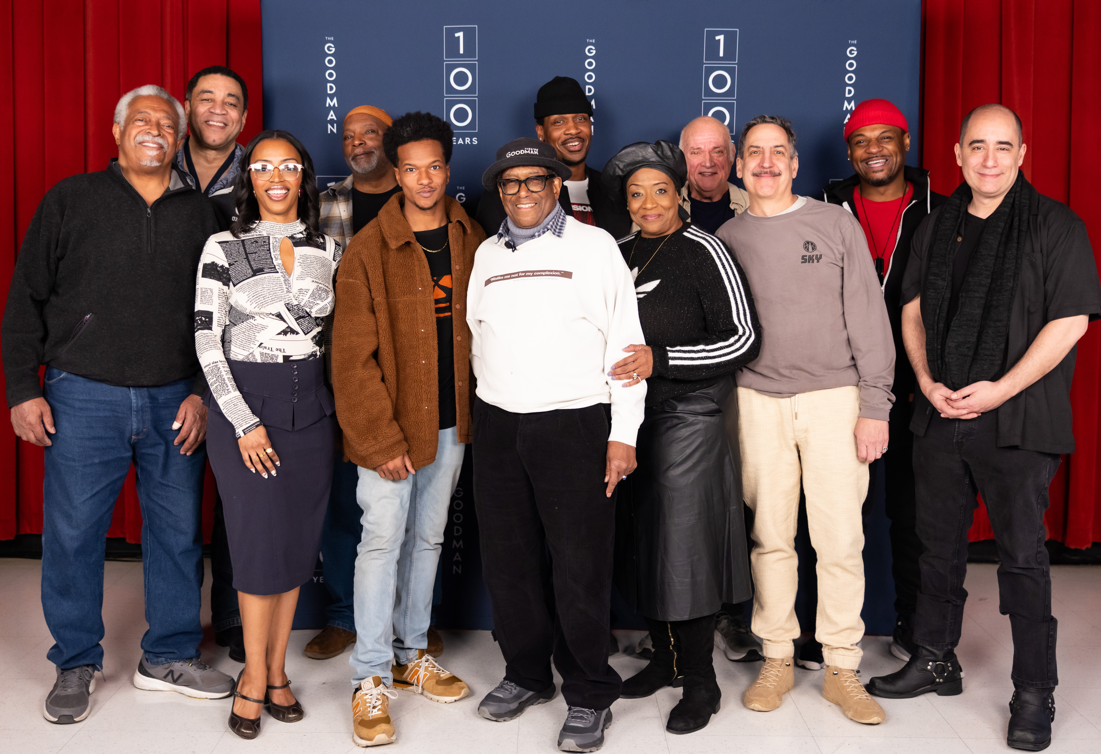
(CHICAGO, IL) Nearly 30 years after its box-office-record-setting 1997 Chicago premiere production, August Wilson’s Ma Rainey‘s Black Bottom returns to The Goodman, helmed by Chicago legends Chuck Smith (Director) and Harry J. Lennix (Music Director). Get a peek into the rehearsal room of Smith’s all-Chicago cast, including E. Faye Butler (Fat Ham), Al’Jaleel McGhee (Revolution(s)), Scott Aiello (Chicago Shakespeare Theatre’s Hamlet), David Alan Anderson (Writers Theatre’s Stick Fly), Matt DeCaro (The Cherry Orchard), Marc Grapey (The Iceman Cometh), Tiffany Renee Johnson (Holiday), Jabari Khaliq (Toni Stone), Kelvin Rostin Jr. (Gem of the Ocean) and Cedric Young (Inherit the Wind). Understudies include Wydetta Carter (Court Theatre’s Porgy and Bess), Robert Cornelius (Lottery Day), Isis Elizabeth (Paramount Theatre’s Brighter Future), Patrick Newson Jr. (BUST), Joseph Primes (BUST) and Ron E. Rains (Holiday). Special events related to the production include Ma Rainey's Black Affinity Night (April 10) and College Night (April 22). More details below. Ma Rainey's Black Bottom appears March 28 through April 26 in the 856-seat Albert Theatre; opening night is April 6. For tickets ($34-$104, subject to change), visit the Box Office (170 N. Dearborn), call 312.443.3800 or visit GoodmanTheatre.org/MaRaineys. The Goodman is grateful for the support of Allstate Insurance Company (Lead Corporate Sponsor), The Elizabeth Morse Charitable Trust (Lead Sponsor of IDEAA Programming), The National Endowment for the Arts (Production Support), PAXXUS (Corporate Sponsor Partner) and WBEZ Chicago (Media Sponsor).

“When The Goodman was in the process of producing all ten plays in the August Wilson cycle for the first time, I had the opportunity to direct only one—Ma Rainey’s Black Bottom, featuring Harry Lennix as Levee. Now, I’ve got Harry as Music Director and sound designers Rob Milburn and Michael Bodeen with me to do it again,” said Goodman Family Resident Director Chuck Smith, who directed The Goodman’s acclaimed 1997 production. “One person I miss having in the room is August Wilson, who was there in 1997. His work and advice led to the creation of a very special production that set a box office record at that time. I know we will all work to make something like that happen again. I’m feeling very good about what’s happening here already!”

“There are few legacies in American theater that rival Chuck Smith's. Actor, educator, theater founder, director—Chuck has spent decades enriching the theater scene in Chicago and beyond,” said Walter Artistic Director Susan V. Booth. “And while his repertoire as a director is wide, it is when he takes on the work of another legend—August Wilson—that the measure of his impact is most deeply felt. To have him revisit this seminal Chicago work in our theater’s Centennial Season feels right in every way.”

It’s 1927 Chicago, and Ma Rainey (E. Faye Butler), “The Mother of the Blues,” takes her time getting ready to record. Tensions and temperatures rise as the musicians recount tales of rage, joy, betrayal and faith in astonishing stories and a heart-stopping climax. Chicago legends Chuck Smith and Harry J. Lennix reunite to make magic again with a “genuine American masterpiece” (Chicago Reader).

SPECIAL EVENTS

Ma Rainey’s Black Affinity Night
April 10 | 6pm
Tickets: $50 (event + show admission)

This pre-show event is designed for those who identify as Black and offers a unique opportunity to explore the cultural roots and musical legacy that shaped the 1920s—and beyond. The evening will feature a Live DJ Set and conversation with Rae Taylor (DJ Rae Chardonnay), the 2025 DJ Scholar-in-Residence for the Renaissance Project. Use code BLACKAFFINITY when purchasing a ticket for this performance online.

College Night
April 22 | 6pm
Tickets: $13 (reception + show admission)

For less than the price of a movie ticket, college students are invited to experience Ma Rainey’s Black Bottom—along with a pre-show reception including all-you-can-eat pizza, soda and a discussion with a member of Goodman’s Artistic Team. Use code COLLEGE when purchasing a ticket for this performance online; a valid college ID will be required to pick up tickets at will call.

ABOUT THE ARTISTS

August Wilson (April 27, 1945–October 2, 2005) authored Gem of the Ocean, Joe Turner’s Come and Gone, Ma Rainey’s Black Bottom, The Piano Lesson, Seven Guitars, Fences, Two Trains Running, Jitney, King Hedley II and Radio Golf. These works explore the heritage and experience of African Americans, decade-by-decade, over the course of the twentieth century. His plays have been produced at regional theaters across the country and all over the world, as well as on Broadway. In 2003, Mr. Wilson made his professional stage debut in his one-man show, How I Learned What I Learned. Mr. Wilson’s works garnered many awards including Pulitzer Prizes for Fences (1987)and The Piano Lesson (1990); a Tony Award for Fences; Great Britain’s Olivier Aware for Jitney; as well as eight New York Drama Critics Circle Awards for Ma Rainey’s Black Bottom, Fences, Joe Turner’s Come and Gone, The Piano Lesson, Two Trains Running, Seven Guitars, Jitney and Radio Golf. Additionally, the cast recording of Ma Rainey’s Black Bottom received a 1985 Grammy Award, and Mr. Wilson received a 1995 Emmy Award nomination for his screenplay adaptation of The Piano Lesson. Mr. Wilson’s early works included the one-act plays The Janitor, Recycle, The Coldest Day of the Year, Malcolm X, The Homecoming and the musical satire Black Bart and the Sacred Hills. Mr. Wilson received many fellowships and awards, including Rockefeller and Guggenheim Fellowships in Playwrighting, The Whiting Writers Award, 2003 Heinz Award, was awarded a 1999 National Humanities Medal by the President of the United States and received numerous honorary degrees from colleges and universities, as well as the only high school diploma ever issued by the Carnegie Library of Pittsburgh. He was an alumnus of New Dramatists, a member of the American Academy of Arts and Sciences, a 1995 inductee into the American Academy of Arts and Letters and on October 16, 2005, Broadway renamed the theater located at 245 West 52nd Street The August Wilson Theatre. Additionally, Mr. Wilson was posthumously inducted into the Theater Hall of Fame in 2007.

Chuck Smith is The Goodman Family Resident Director, Board of Trustees member and resident director at the Westcoast Black Theatre Troupe in Sarasota. Mr. Smith's Goodman credits include Objects in the Mirror, Two Trains Running, Pullman Porter Blues, By the Way, Meet Vera Stark and The Amen Corner, among many others. He also served as dramaturg for the Goodman’s world-premiere of August Wilson’s Gem of the Ocean. Regionally and locally, he has directed at the Oregon Shakespeare Festival, Milwaukee Repertory Theater, Seattle Repertory Theatre, MPAACT, American Blues, Black Ensemble Theatre, and Congo Square Theatre Company, among others. Mr. Smith is an Emmy Award-winner, a recipient of the Paul Robeson Award and was the 2001 Chicago Tribune Chicagoan of the Year.

Harry J. Lennix is a distinguished film, television stage actor and producer. He returns to Goodman Theatre following productions of Inherit the Wind, August Wilson’s How I Learned What I Learned (produced by Congo Square in association with The Goodman) and Ma Rainey’s Black Bottom, directed by Chuck Smith. Recently at Steppenwolf Theatre, he appeared in Purpose. He also appeared in Purpose on Broadway and was Tony-nominated in the Lead Actor in a Play category. He starred for 10 seasons on NBC’s The Blacklist. Moviegoers know Lennix from The Justice League, Man of Steel, Batman V. Superman: Dawn of Justice, The Matrix: Reloaded, The Matrix: Revolutions, Ray and The Five Heartbeats. Lennix also recurred for 7 seasons on the Showtime series Billions. Lennix made his Broadway debut in Radio Golf. He has directed A Small Oak Tree Runs Red, The Five Heartbeats and The Glass Menagerie. He has starred in King Hedley II at the Mark Taper Forum and in 2001 he played in Cymbeline for Theatre for a New Audience at the Royal Shakespeare Company. In July 2014, Lennix created Exponent Media Group.

Cast of August Wilson’s Ma Rainey’s Black Bottom (in alphabetical order)
Directed by Chuck Smith
Music Director & Associate Director Harry J. Lennix

Scott Aiello...Policeman/US Sturdyvant
David Alan Anderson...Cutler
E. Faye Butler...Ma Rainey
Matt DeCaro...Sturdy
Marc Grapey...Irvin
Tiffany Renee Johnson...Dussie Mae
Jabari Khaliq...Sylvester/US Levee
Al’Jaleel McGhee...Levee
Kelvin Roston Jr....Toledo
Cedric Young...Slow Drag

Understudies include Wydetta Carter (Ma Rainey), Robert Cornelius (Toledo), Isis Elizabeth (Dussie Mae), Patrick Newson Jr. (Levee/Sylvester), Joseph Primes (Slow Drag/Cutler) and Ron E. Rains (Irvin/Policeman).

Creative Team

Co-Sound Designer...Michael Bodeen
Co-Sound Designer...Rob Milburn
Costume Designer...Evelyn Danner
Lighting Designer...Jared Gooding
Set Designer...Linda Buchanan
Orchestrations...Dwight Andrews
Intimacy and Violence...Greg Geffrard
Voice Coach...Marie Ramirez Downing
Bass Coach...Anderson Edwards
Line Producer...Malkia Stampley
Assistant Director...Lo Williams
Intimacy and Violence Assistant...Chels Morgan
Assistant Lighting Designer...Trey Brazeal
Assistant Sound Designer...Kim Carbone

Casting is by Lauren Port, CSA. Neena Arndt is the Dramaturg. Angela Adams is the Production Stage Manager. Imani Ross is the Stage Manager.

ENHANCED AND ACCESSIBLE PERFORMANCES
Visit GoodmanTheatre.org/Access for more information about The Goodman’s accessibility efforts.

ASL-Interpreted...April 17 at 7:30pm – An ASL interpreter signs the action/text as played.
Audio-Described...April 18 at 2pm; Touch Tour; 12:30pm – Action audibly enhanced via headset.
Spanish-Subtitled...April 18 at 7:30pm – Spanish-translated dialogue via LED sign.
Open-Captioned...April 19 at 2pm – LED sign presents dialogue in sync with the performance.

ABOUT THE GOODMAN

Since 1925, The Goodman has been more than a stage. A theatrical home for artists and a gathering space for community, it’s where stories come to life—bold in artistry and rich in history, deeply rooted in the city it serves.

Led by Walter Artistic Director Susan V. Booth and Executive Director John Collins, The Goodman sparks conversation, connection and change through new plays, reimagined classics and large-scale musicals. With distinctions including nearly 200 world or American premieres, two Pulitzer Prizes, 22 Tony Awards and nearly 200 Joseph Jefferson Awards, The Goodman is proud to be the first theater to produce all 10 plays of August Wilson’s “American Century Cycle.” In addition, the theater frequently serves as a production partner—with national and international companies to Chicago’s Off-Loop theaters—to help amplify theatrical voices.

But The Goodman believes a more empathetic, more connected Chicago is created one story at a time, and counts as its greatest legacy the community it’s built. Generation-spanning productions and programs offer theater for a lifetime; from Theater for the Very Young (plays designed for ages 0-5) to the long-running annual A Christmas Carol, which has introduced new generations to theater over five decades, The Goodman is committed to being an asset for all of Chicago. Education and Engagement programs led by Clifford Director of Education and Engagement Jared Bellot and housed in the Alice Rapoport Center use the tools of theater to spark imagination, reflection and belonging. Each year, these programs reach thousands of people (85% from underserved communities) as well as educators, artists and lifelong learners across the city.

The Goodman stands on the unceded homelands of the Council of the Three Fires—the Ojibwe, Odawa, and Potawatomi Nations—and acknowledges the many other Nations for whom this land now called Chicago has long been home, including the Myaamia, Ho-Chunk, Menominee, Sac and Fox, Peoria, Kaskaskia, Wea, Kickapoo, and Mascouten. The Goodman is proud to partner with the Gichigamiin Indigenous Nations Museum (Gichigamiin-Museum.org) and the Center for Native Futures (CenterForNativeFutures.org)—organizations devoted to honoring Indigenous stories, preserving cultural memory, and deepening public understanding.

The Goodman was founded by William O. Goodman and his family to honor the memory of Kenneth Sawyer Goodman—a visionary playwright whose bold ideas helped shape Chicago’s early cultural renaissance. That spirit of creativity and generosity endures today. In 2000, through the commitment of Mr. Goodman’s descendants—Albert Ivar Goodman and his late mother, Edith-Marie Appleton—The Goodman opened the doors to its current home in the heart of the Loop.

Marsha Cruzan is Chair of the Goodman Theatre Board of Trustees; Diane Landgren is Women’s Board President; and Kelli Garcia is president of the Scenemakers Board for Young Professionals.

—30—

