CONTACT: Jamie Hiskes/Denise Schneider FOR IMMEDIATE RELEASE
312.443.5569 or Press@GoodmanTheatre.org October 23, 2025
IMAGES: Goodman Theatre Press Room

CHRISTOPHER DONAHUE RETURNS AS SCROOGE, 9-YEAR-OLD ELLA BOPARAI DEBUTS AS TINY TIM IN THE GOODMAN’S 48TH ANNUAL PRODUCTION OF A CHRISTMAS CAROL, NOVEMBER 15 – DECEMBER 31

**DIRECTED FOR THE FIRST TIME BY MALKIA STAMPLEY, THIS YEAR’S 34-PERSON COMPANY INCLUDES
FRESH FACES AND FAMILIAR FAVORITES**

***CHIKÉ JOHNSON (ASHLAND AVENUE) APPEARS AS SCROOGE IN 10 PERFORMANCES***

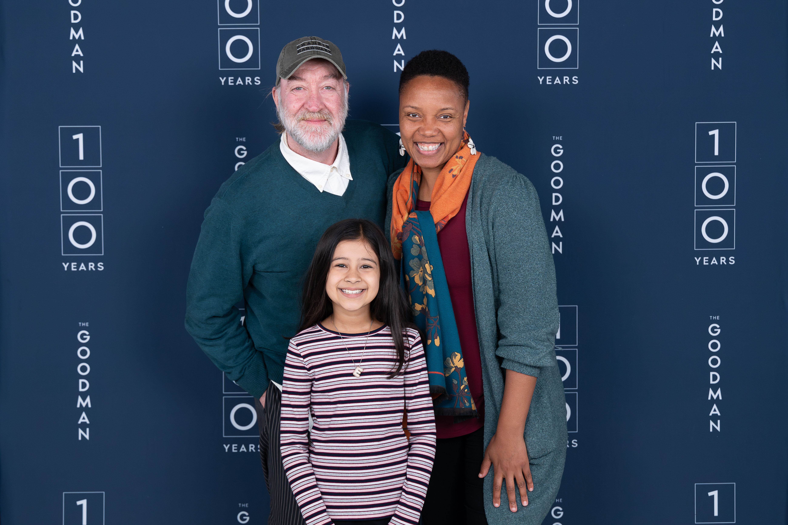
(CHICAGO, IL) Holiday cheer returns to The Goodman for the 48th consecutive year with the Centennial Season production of Charles Dickens’ A Christmas Carol. Directed for the first time by BOLD Artistic Producer Malkia Stampley, the cast features Christopher Donahue returning for his second year as Ebenezer Scrooge, Ella Boparai (Joffrey Ballet’s Nutcracker) making her Goodman debut as Tiny Tim and Chiké Johnson (Ashland Avenue) performing as Scrooge for 10 shows. Performers joining the cast of this beloved Chicago holiday tradition for the first time include Christiana Clark (Primary Trust), Elleon Dobias (Writers Theatre’s Once), Benjamin Heppner, Chris Khoshaba (Layalina), Helen Joo Lee (The Antiquities), Isabelle Muthia (Metropolis Theater’s Dear Jack, Dear Louise), Sól Fuller (Raven Theatre’s The Prodigal Daughter), Mizha Lee Overn (Kokandy Productions’ Amélie the Musical) and young performers A’mia Imani (Uptown Music Theatre’s Hairspray) Carmelo Kelly (Beverly Arts Center’s Oliver) and Sebastian Rus (Lodge Arts Center’s The Lion King Jr.). Boparai, Imani, Kelly and Rus are joined by two returning young performers: Viva Boresi and Henry Lombardo. A Christmas Carol runs November 15 through December 31 (opening night is November 23) in the 856-seat Albert Theatre. For tickets ($34 - $173, subject to change), visit the Box Office (170 N. Dearborn), call 312.443.3800 or purchase online at GoodmanTheatre.org/Carol. Visit the website for performance dates when Johnson appears as Scrooge.
Left to right: Christopher Donahue (Scrooge), Ella Boparai (Tiny Tim) and director Malkia Stampley. (Photo by Hugo Hentoff)

“Right now, there’s a community of theater artists across the country working on their own productions of A Christmas Carol. I can’t think of anything else we do at The Goodman that feels so synchronistic, connected and wonderful—especially when stories of redemption, of soul, are so deeply necessary,” said Walter Artistic Director Susan V. Booth. “And it’s essential that the director possesses, at once, fantastic craft and an enormous heart. It is my delight that this year at The Goodman, that torch is passed to Malkia Stampley.”

“I think about the three ghosts who visit Scrooge, challenge him, and ultimately make him better. And then I think about the ghosts in my life,” said director Malkia Stampley. “Theater is a huge ghost of mine that constantly challenges me to ask, ‘How can I be a better human? How can I better tell a story that fits yesterday, today and tomorrow? Who can I help, and what help do I need?’ Theater challenges that, in all of us. And A Christmas Carol is one of the greatest expressions of that challenge. Directing this show is a gift, and I am humbled.”

Rediscover Dickens’ classic with an adaptation that “makes you believe kindness can win” (Chicago Tribune). Follow Ebenezer Scrooge, a businessman whose disdain for the holidays is transformed on Christmas Eve. Featuring a “first-rate cast and marvelous staging” (Chicago Sun-Times), this tale remains “the best Christmas story ever told” (Time Out Chicago).

The Goodman is grateful for the support of PNC (Major Corporate Sponsor) and ITW (Corporate Sponsor Partner).

Christopher Donahue (Scrooge) has appeared at The Goodman in The Baltimore Waltz, The Notebooks of Leonardo Da Vinci, Arcadia, Journey to the West, The Odyssey, Silk, The Cherry Orchard and A Christmas Carol. In Chicago, he's worked at Court Theatre, Lookingglass, Chicago Opera Theatre, Chicago Shakespeare Theatre, Annoyance Theatre, Remains Theatre and Stories on Stage. He has performed at many theaters across the country, most recently as the Stage Manager in Mary Zimmerman's production of Our Town at Cleveland Play House.

Ella Boparai, she/her (Tiny Tim) is delighted to make her Goodman Theatre debut. Boparai previously performed in the Joffrey Ballet’s 2024 production of The Nutcracker. She is in her third year with the competitive dance team at Visceral Dance Studio, where she studies ballet, contemporary and jazz. Boparai discovered her love of theater under the guidance of Wendy Andrews and through performances in school musicals. Other credits include various locally-filmed commercials. In her free time, Boparai studies piano, voice and French. Boparai is proudly represented by Big Mouth Talent.

Chiké Johnson (Alternate Scrooge) was most recently seen in Goodman Theatre’s production of Ashland Avenue. Other credits at The Goodman include Toni Stone. Johnson is a company member of Remy Bumppo Theatre and has worked on many stages in Chicago and around the country. Some of his Chicago credits include: Northlight's production of Birthday Candles; Remy Bumppo’s world premiere production of Galileo’s Daughter; and the world premiere of When Harry Met Rehab at the Greenhouse Theater Center. Regional credits include: American Player’s Theatre’s Ma Rainy’s Black Bottom and King Lear. New York credits include: Ruined at Manhattan Theatre Club; RunBoyRun at New York Theatre Workshop; and New York City Center’s Encores Lost in the Stars. His Broadway credits include Time to Kill and Wit.

Malkia Stampley, she/her (Director) is a twice Jeff-nominated director from Milwaukee and The Goodman’s BOLD Artistic Producer since 2021. Goodman Theatre directing credits: BUST (associate director), Primary Trust, In My Granny’s Garden, New Stages' Cephianne's Reflection. Additional directing: Rivendell, Raven, Definition, Congo Square, TimeLine, Court, Chicago Shakespeare, Stage Left, Kansas City Rep, Orlando Shakespeare, Milwaukee Rep, Milwaukee Chamber, Skylight Music, Black Arts MKE, Northern Sky, American Players, Farmers Alley, Northwestern, First Stage, Inc. Co-founder: Milwaukee Black Theater Festival, Bronzeville Arts Ensemble.

Full company of A Christmas Carol (in alphabetical order)
By Charles Dickens
Adapted by Tom Creamer
Directed by Malkia Stampley

Jazzlyn Luckett Aderele...Maxine Fezziwig/Ensemble/Abigail
Ella Boparai...Tiny Tim/Want
Viva Boresi...Belinda Cratchit
Tatiana Bustamante...Belle/Ensemble
Christiana Clark...Mrs. Fezziwig/Mrs. Dilber
Amira Danan...Frida
Elleon Dobias...Musician
Christopher Donahue...Ebenezer Scrooge
Arash Fakhrabadi...Young Scrooge/Ensemble/Undertaker
Sól Fuller...Martha Cratchit/Ensemble/Fan/Catherine
Brian A. Goodwin...Musician
Jalbelly Guzmán...Felicity/Ensemble/Hat Seller
Benjamin Heppner...Musician
Gregory Hirte...Musician
A’mia Imani...Emily Cratchit
Anthony Irons...Ortle/School Official/Old Joe
Chiké Johnson...Alternate Scrooge
Carmelo Kelly...Gregory Cratchit/Newspaper Seller/Ignorance/Turkey Child
Chris Khoshaba...Dick Wilkins/Ensemble
Helen Joo Lee...Mrs. Cratchit
Henry Lombardo...Peter Cratchit/Boy Scrooge
Daniel José Molina...Marley/Ghost of Christmas Future
Isabelle Muthiah...Ensemble/Chestnut Seller
Jon Hudson Odom...Bob Cratchit
Robert Schleifer...Mr. Fezziwig
Lucky Stiff...Ghost of Christmas Past/Topper/Makeup Consultant for Christmas Past
Bethany Thomas...Charwoman/Ghost of Christmas Present
Austin Tichenor...Crumb

Understudies for this production include Hillary Bayley, Jordan Golding, Loren Jones, Mizha Lee Overn, Sebastian Rus and Anne Sheridan Smith.

Creative Team

Choreographer...Tor Campbell
Composer...Andy Hansen
Music Director...Gregory Hirte
Fly Director...Andrea Gentry
Voice & Dialect Coach...Michelle Lopez-Rios
Assistant Director...Michael Cotey
Assistant Choreographer...Jalbelly Guzmán
Line Producer...Lena Romano
Costume Designer...Heidi Sue McMath
Lighting Designer...Keith Parham
Associate Lighting Designer...Brian Elston
Set Designer...Todd Rosenthal
Sound Designer...Pornchanok “Nok” Kanchanabanca
Assistant Sound Designer...Hannah Kwak
Script Production Assistant...Jojo Wallenberg
Young Performer Supervisors...Gabriel Anderle and Hope X. Still

Casting is by Lauren Port, CSA. Jennifer Gregory is the Production Stage Manager. Beth Koehler and Duncan McMillan are the Stage Managers. Additional adaptive work by Neena Arndt.

ENHANCED AND ACCESSIBLE PERFORMANCES
Visit GoodmanTheatre.org/Access for more information about The Goodman’s accessibility efforts.

ASL-Interpreted...December 5 at 7:30pm – An ASL interpreter signs the action/text as played.
Audio-Described...December 6 at 2pm; Touch Tour; 12:30pm – Action audibly enhanced via headset.
Spanish-Subtitled...December 7 at 7pm – Spanish-translated dialogue via LED sign.
Open-Captioned...December 7 at 2pm – LED sign presents dialogue in sync with the performance.
Sensory-Friendly...December 28 at 2pm – Softer lighting and sound; sensory items available for use.

ABOUT THE GOODMAN

Since 1925, The Goodman has been more than a stage. A theatrical home for artists and a gathering space for community, it’s where stories come to life—bold in artistry and rich in history, deeply rooted in the city it serves.

Led by Walter Artistic Director Susan V. Booth and Executive Director John Collins, The Goodman sparks conversation, connection and change through new plays, reimagined classics and large-scale musicals. With distinctions including nearly 200 world or American premieres, two Pulitzer Prizes, 22 Tony Awards and nearly 200 Joseph Jefferson Awards, The Goodman is proud to be the first theater to produce all 10 plays of August Wilson’s “American Century Cycle.” In addition, the theater frequently serves as a production partner—with national and international companies to Chicago’s Off-Loop theaters—to help amplify theatrical voices.

But The Goodman believes a more empathetic, more connected Chicago is created one story at a time, and counts as its greatest legacy the community it’s built. Generation-spanning productions and programs offer theater for a lifetime; from Theater for the Very Young (plays designed for ages 0-5) to the long-running annual A Christmas Carol, which has introduced new generations to theater over five decades, The Goodman is committed to being an asset for all of Chicago. Education and Engagement programs led by Clifford Director of Education and Engagement Jared Bellot and housed in the Alice Rapoport Center use the tools of theater to spark imagination, reflection and belonging. Each year, these programs reach thousands of people (85% from underserved communities) as well as educators, artists and lifelong learners across the city.

The Goodman stands on the unceded homelands of the Council of the Three Fires—the Ojibwe, Odawa, and Potawatomi Nations—and acknowledges the many other Nations for whom this land now called Chicago has long been home, including the Myaamia, Ho-Chunk, Menominee, Sac and Fox, Peoria, Kaskaskia, Wea, Kickapoo, and Mascouten. The Goodman is proud to partner with the Gichigamiin Indigenous Nations Museum (Gichigamiin-Museum.org) and the Center for Native Futures (CenterForNativeFutures.org)—organizations devoted to honoring Indigenous stories, preserving cultural memory, and deepening public understanding.

The Goodman was founded by William O. Goodman and his family to honor the memory of Kenneth Sawyer Goodman—a visionary playwright whose bold ideas helped shape Chicago’s early cultural renaissance. That spirit of creativity and generosity endures today. In 2000, through the commitment of Mr. Goodman’s descendants—Albert Ivar Goodman and his late mother, Edith-Marie Appleton—The Goodman opened the doors to its current home in the heart of the Loop.

—30—

