CONTACT: Denise Schneider/Jamie Hiskes **FOR IMMEDIATE RELEASE**

312.443.5151 or [Press@GoodmanTheatre.org](mailto:Press@GoodmanTheatre.org) **August 20, 2025**

IMAGES: [Goodman Theatre Press Room](https://www.dropbox.com/scl/fo/c7icjzygjslugm7satgsu/AHTWmgaNFTNCRbx5-Bql4S8?rlkey=xgdasw8s5edb30nab3bmcg8zh&st=sqoeibcj&dl=0)

[**A FIRST LOOK**](https://www.dropbox.com/scl/fo/c7icjzygjslugm7satgsu/AHTWmgaNFTNCRbx5-Bql4S8?rlkey=xgdasw8s5edb30nab3bmcg8zh&st=sqoeibcj&dl=0) **AT *ASHLAND AVENUE,* A CHICAGO STORY BY LEE KIRK, NOW IN REHEARSAL**

**\*\*\*SUSAN V. BOOTH’S WORLD-PREMIERE PRODUCTION STARS JENNA FISCHER AND FRANCIS GUINAN,**

**WITH WILL ALLAN, CORDELIA DEWDNEY AND CHIKÉ JOHNSON, APPEARS SEPTEMBER 6 – OCTOBER 5\*\*\***

(CHICAGO, IL) A local business, a stubborn heart, a lively city street and the quiet moments when a family begins to change come center stage in **Lee Kirk**’s *Ashland Avenue*—the new play that launches The Goodman’s Centennial 2025/2026 Season next month. Walter Artistic Director **Susan V. Booth** directs the world-premiere production featuring Emmy Award-nominee **Jenna Fischer** (*The Office*’s Pam Beesly) and Chicago’s own **Francis Guinan** (*The Cherry Orchard*), with **Will Allan** (*The Cherry Orchard*), **Cordelia Dewdney** (Drury Lane’s *Steel Magnolias*) and **Chiké Johnson** (*Toni Stone*). *Ashland Avenue* 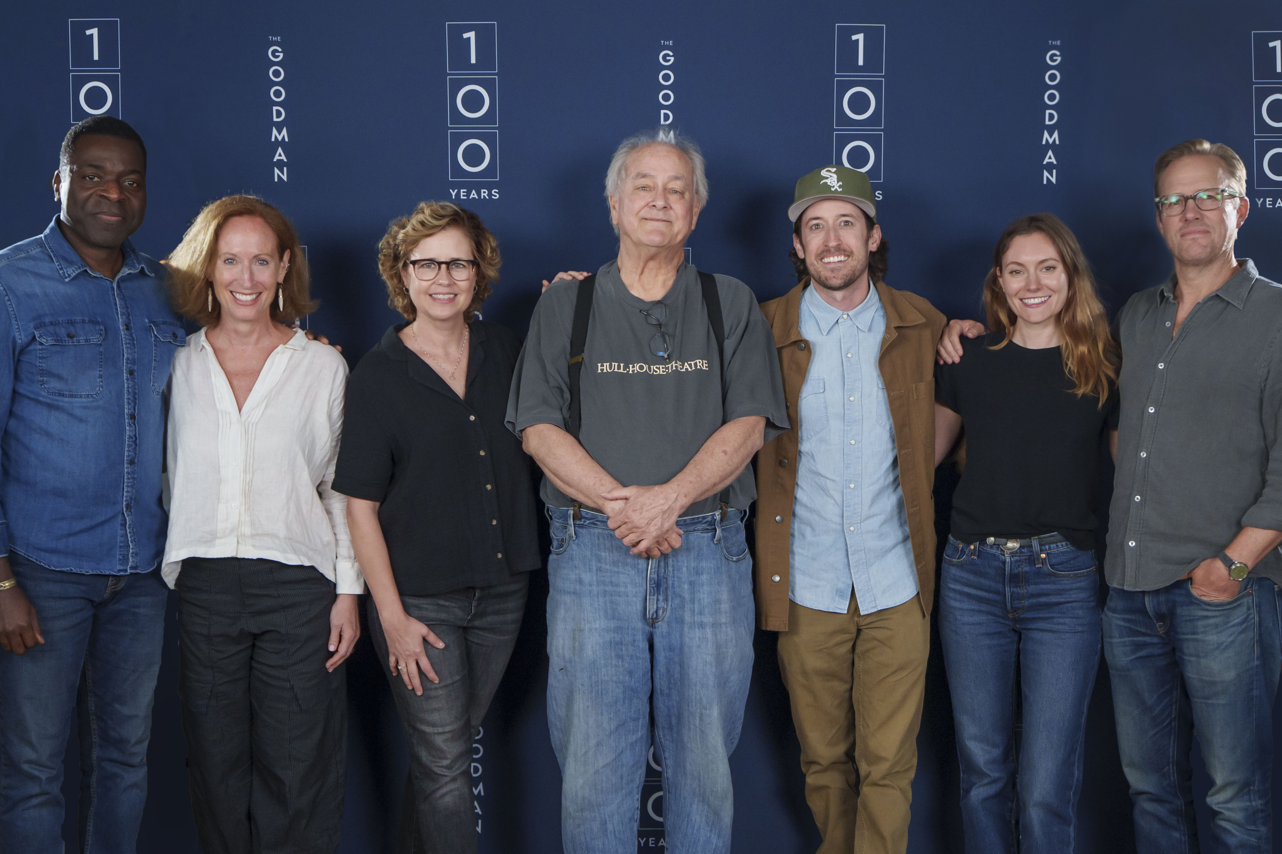

appears September 6 – October 5 (Opening Night is September 15) in the 856-seat Albert Theatre. Tickets ($33-$148) are on sale now; visit the Box Office (170 N. Dearborn), call 312.443.3800 or purchase online at [GoodmanTheatre.org/Ashland](https://www.goodmantheatre.org/show/ashland-avenue/).

“Last December, following a reading of *Ashland Avenue* for a few hundred intrepid souls who attend 10am Saturday play readings, there was a line of people waiting to talk—to Lee, to me, to anyone associated with the play. And while they said some nice things about the play, that isn’t what they wanted to talk about. They wanted to tell us about kids who’d moved away. About family businesses that now were no more. About aspirations they had, but weren’t ready to share—and yet, here they were, sharing them,” said **Susan V. Booth**. “When a play opens up its audience like that, we all get a little more human in that space. And we certainly can use more of that right now.”

Pete’s TV and Video has served Chicagoland for 40+ years, its plucky owner famous for his legendary commercials and customer care. But it’s a new era, and Pete’s (**Fran Guinan**) last store location is struggling while Sam (**Jenna Fischer**)—his daughter and family business heir apparent—has different dreams. This hilarious and moving new play asks what happens when we step outside of our parents' footsteps to follow our heart?

“I started writing *Ashland Avenue* after a visit to Chicago in 2023. It was on this trip when I realized, sadly, that many of my old college haunts were no longer in existence,” said playwright **Lee Kirk**. “Although I hadn’t thought of them in years, I was instantly nostalgic for places like The Three penny Cinema, Taco Burrito Place #2 and the legendary Lounge Ax. But my longing gave me an idea—and by the time I’d returned to Los Angeles three days later, the seeds of *Ashland Avenue* had been planted.”

A graduate of The Theater School at DePaul University, where he studied Acting, Kirk’s feature films as writer/director include *Ordinary World*, starring Billie Joe Armstrong (Green Day), Selma Blair, Judy Greer and Fred Armisen. *The Giant Mechanical Man*, starring Jenna Fischer, Chris Messina, Topher Grace with Bob Odenkirk. And the upcoming film *New Years Rev: A Green Day Movie*. Playwright: *Sad Happy Sucker,* originally produced in 2007 in Los Angeles, produced 2019 Trap Door Theater, Chicago. Music Video/Director: Old 97’s *Good With God*. Television/Director: NBC comedy, *The Office*.

The Goodman is grateful for the support of JPMorgan Chase & Co. (Lead Corporate Sponsor), Edgerton Foundation (New Play Award), Abbott Fund and Winston & Strawn LLP (Corporate Sponsor Partners).

**THE COMPANY OF *ASHLAND AVENUE***

**Will Allan** (Young Man) Chicago credits include *The Cherry Orchard, The Winter’s Tale, Ah, Wilderness!, Dartmoor Prison* and *The Seagull* (Goodman Theatre); *Good People, The Flick, Animal Farm, We are Proud to Present…, The March* and *A Separate Peace* (Steppenwolf Theatre); *The Whale* (Victory Gardens); *The History Boys* (TimeLine Theatre); and many more. He is also a Company Member with TimeLine Theatre and can next be seen in Chicago in their upcoming production of *An Enemy of the People*, which will open their new theater in Uptown in May of 2026.

**Cordelia Dewdney** (Jess) Chicago credits include *Steel Magnolias* (Drury Lane); *Mr. Dickens' Hat* (Northlight Theatre); *Moby Dick, Hard Times*, Mary Shelley's *Frankenstein* (Lookingglass Theatre). Regional work includes *The Seagull* (Pasadena Theatre Workshop); *Moby Dick* (The Alliance Theatre, Arena Stage, and South Coast Repertory); Mary Shelley's *Frankenstein* (The McCarter Theatre). Television credits include *Chicago Med* and *South Side*. She is represented by Stewart Talent.

**Jenna Fischer** (Sam) is a film, television and theater actor making her Goodman Theatre debut. She starred Off-Broadway in *Reasons to Be Happy* by Neil LaBute and in the world premiere of Steve Martin's play *Meteor Shower* at the Old Globe Theatre. Best known for playing Pam Beesly on *The Office*, Fischer earned an Emmy nomination for Best Supporting Actress and two SAG Awards for Outstanding Performance by an Ensemble Comedy. She is currently co-host of *The Office* re-watch podcast Office Ladies with Angela Kinsey. Her films credits include *Mean Girls (2024),* *Walk Hard: The Dewey Cox Story, Blades of Glory* and *The Giant Mechanical Man* (which she also produced). She will also appear in the upcoming film *New Years Rev*.

**Francis Guinan** (Pete) Chicago credits: *The Seagull, The Cherry Orchard, The Magic Show, Pullman Porter Blues, Twist Your Dickens* (Goodman Theatre); *August: Osage County, Downstate, The Night Alive, The Seafarer, Balm In Gilead, American Buffalo* (Steppenwolf Theatre); *The White Guy On the Bus, Seasons Greetings* (Northlight Theatre); *Goldfish* (Route 66). Regional: *Twelfth Night* (Huntington Theatre). TV credits: *Chicago Med, Boss, Chicago PD, Eerie, Indiana, L.A. Law, Star Trek, Murder She Wrote*. Film credits: *Relatives, Speed II, Constantine, Henry Gamble's Birthday Party, Ghostlight.*

**Chiké Johnson** (Mike) was most recently seen on American Player’s Theatre’s stage in *Ma Rainey’s Black Bottom* and *King Lear*. Chiké is a company member of Remy Bumppo Theatre and has worked on many stages in Chicago and around the country. Some of his recent Chicago credits include: *Toni Stone* at Goodman Theatre; Northlight's production of *Birthday Candles*; Remy Bumppo’s world premiere production of *Galileo’s Daughter*; and the world premiere of *When Harry Met Rehab* at the Greenhouse Theater Center. Chike’s New York credits include: *Ruined* at Manhattan Theatre Club; *RunBoyRun* at New York Theatre Workshop; and New York City Center’s *Encores Lost in the Stars*. His Broadway credits include *Time to Kill* and *Wit*.

**Susan V. Booth** (Director) joined Goodman Theatre in the fall of 2022, having previously served as Artistic Director of Atlanta’s Tony Award-winning Alliance Theatre, premiering new work that went on to national, international and commercial life. She has directed at The Goodman, Hartford Stage, National Playwrights Conference, The Contemporary American Theater Festival, La Jolla Playhouse, St. Louis Repertory Theatre, Cincinnati Playhouse, New York Stage and Film, Actors Theatre of Louisville, Northlight Theatre, Victory Gardens, Court Theatre and others. She has held teaching positions at Northwestern, DePaul and Emory Universities. She serves on the boards of the Erikson Institute and Denison University, is past president of the Board of Directors for the Theatre Communications Group, the national service organization for the field, was a 2024 Leadership Greater Chicago Daniel Burnham Fellow, and is a member of the Chicago Network.

***Ashland Avenue***

**By Lee Kirk**

**Directed by Susan V. Booth**

**Will Allan…**Young Man

**Cordelia Dewdney…**Jess

**Jenna Fischer…**Sam

**Francis Guinan…**Pete

**Chiké Johnson…**Mike

Understudies for this production include **Daniel Ajak** (Mike), **Adam Benjamin** (Young Man), **Maura Kidwell** (Sam), **Hannah Ruwe** (Jess) and **Don Tieri** (Pete).

**Creative Team**

Line Producer…**Malkia Stampley**

Second Line Producer…**Lena Romano**

Assistant Director…**Michael Coty**

Vocal and Dialect Coach…**Stan Brown**

Fight Choreographer…**Chuck Coyl**

Set Designer…**Kevin Depinet**

Costume Designer…**Jessica Pabst**

Lighting Designer…**Jason Lynch**

Sound Designer and Composer….**Lindsay Jones**

Assistant Sound Designer…**Aaron Woodstein**

Casting is by **Lauren Port**, CSA. **Clara Zucker** is the Dramaturg. **Nikki Blue** is the Production Stage Manager. **Jennifer Gregory** is the Stage Manager.

**ENHANCED AND ACCESSIBLE PERFORMANCES**

*Visit* [*GoodmanTheatre.org/Access*](https://www.goodmantheatre.org/tickets/accessibility/) *for more information about The Goodman’s accessibility efforts.*

ASL-Interpreted: September 26 at 7:30pm – An ASL interpreter signs the action/text as played.

Audio-Described: September 27 at 2pm; Touch Tour; 12:30pm – Action audibly enhanced via headset.

Spanish-Subtitled: September 27 at 7:30pm – Spanish-translated dialogue via LED sign.

Open-Captioned: September 28 at 2pm – LED sign presents dialogue in sync with the performance.

**ABOUT THE GOODMAN**

Since 1925, The Goodman has been more than a stage. A theatrical home for artists and a gathering space for community, it’s where stories come to life—bold in artistry and rich in history, deeply rooted in the city it serves.

Led by Walter Artistic Director **Susan V. Booth** and Executive Director **John Collins**, The Goodman sparks conversation, connection and change through new plays, reimagined classics and large-scale musicals. With distinctions including nearly 200 world or American premieres, two Pulitzer Prizes, 22 Tony Awards and nearly 200 Joseph Jefferson Awards, The Goodman is proud to be the first theater to produce all 10 plays of August Wilson’s “American Century Cycle.” In addition, the theater frequently serves as a production partner—with national and international companies to Chicago’s Off-Loop theaters—to help amplify theatrical voices.

But The Goodman believes a more empathetic, more connected Chicago is created one story at a time, and counts as its greatest legacy the community it’s built. Generation-spanning productions and programs offer theater for a lifetime; from *Theater for the Very Young* (plays designed for ages 0-5) to the long-running annual *A Christmas Carol*, which has introduced new generations to theater over five decades, The Goodman is committed to being an asset for all of Chicago. Education and Engagement programs led by Clifford Director of Education and Engagement **Jared Bellot** and housed in the Alice Rapoport Center use the tools of theater to spark imagination, reflection and belonging. Each year, these programs reach thousands of people (85% from underserved communities) as well as educators, artists and lifelong learners across the city.

The Goodman stands on the unceded homelands of the Council of the Three Fires—the Ojibwe, Odawa, and Potawatomi Nations—and acknowledges the many other Nations for whom this land now called Chicago has long been home, including the Myaamia, Ho-Chunk, Menominee, Sac and Fox, Peoria, Kaskaskia, Wea, Kickapoo, and Mascouten. The Goodman is proud to partner with the Gichigamiin Indigenous Nations Museum ([Gichigamiin-Museum.org](https://gichigamiin-museum.org/)) and the Center for Native Futures ([CenterForNativeFutures.org](https://www.centerfornativefutures.org/))—organizations devoted to honoring Indigenous stories, preserving cultural memory, and deepening public understanding.

The Goodman was founded by William O. Goodman and his family to honor the memory of Kenneth Sawyer Goodman—a visionary playwright whose bold ideas helped shape Chicago’s early cultural renaissance. That spirit of creativity and generosity endures today. In 2000, through the commitment of Mr. Goodman’s descendants—Albert Ivar Goodman and his late mother, Edith-Marie Appleton—The Goodman opened the doors to its current home in the heart of the Loop.

—30—