CONTACT: Denise Schneider and Ata Younan FOR IMMEDIATE RELEASE
312.443.5151 or Press@GoodmanTheatre.org March 11, 2024
IMAGES: Goodman Press Room

JENNIFER MORRISON AND AN ALL-FEMALE, ALL-CHICAGO CAST OPEN THE PENELOPIAD TONIGHT

PHOTO AND VIDEO ARE NOW AVAILABLE FOR THE CHICAGO PREMIERE OF SUSAN V. BOOTH’S DIRECTORIAL DEBUT, MARGARET ATWOOD’S FEMINIST RETELLING OF A GREEK CLASSIC

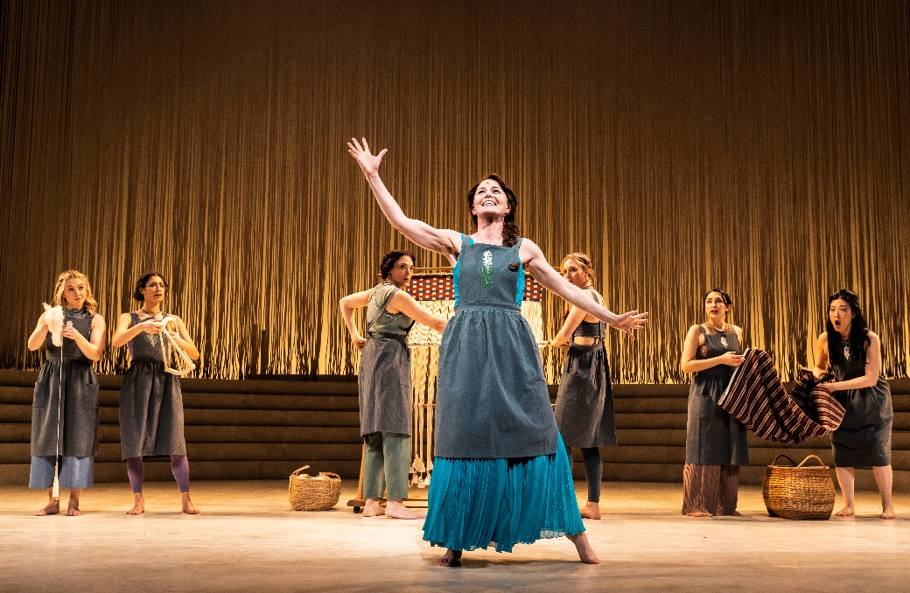
(Chicago, IL) New Goodman Artistic Director Susan V. Booth makes her directorial debut with the opening of The Penelopiad. Jennifer Morrison (Once Upon a Time, House) in the title role of the Chicago premiere leads an all-female, all Chicago cast in this ancient tale told anew, with choreography by JoAnn M. Hunter. The design team includes Neil Patel (Sets); Kara Harmon (Costumes); Xavier Pierce (Lighting); Willow James (Sound); Samuel Davis (Music Composition); Jeremy Ramey (Music Direction); and Neena Arndt (Dramaturg). Kimberly McCann is the Production Stage Manager and Jennifer Gregory is the Stage Manager. Goodman Theatre’s Women’s Board is the Major Production Sponsor of The Penelopiad; The BOLD Theater Women’s Leadership Circle is the Production Sponsor; the National Endowment for the Arts provides Production Support; and Winston & Strawn LLP is the Corporate Sponsor Partner. The Penelopiad appears March 2 – 31 in the 856-seat Albert Theatre. Tickets ($25 – 90; subject to change) are available at GoodmanTheatre.org/Penelopiad or by phone at 312.443.3800.

Access photos and video of the production here.
An unexpected remix of Homer’s The Odyssey, told by the celebrated and subversive author Margaret Atwood (The Handmaid’s Tale). It’s her turn. Penelope has waited 20 years for her husband to return from the Trojan War. Now, as authorial control shifts to Odysseus’ long-suffering wife—and the 12 faithful maids who have long tended to her—we discover a new perspective on the domestic vigil. This ancient tale told anew by “one of the most admired authors in North America” (NPR) gives voice to those left behind.
ABOUT THE COMPANY (in alphabetical order)
For images, bios and additional information about the artists, visit the Play Detail Page.

The Penelopiad
By Margaret Atwood
Directed by Susan V. Booth
March 3 – March 31

Aja Alcazar…Maid
Demetra Dee…Maid
Maya Lou Hlava….Maid
Noelle Kayser…Maid
Elizabeth Laidlaw….Maid
Helen Joo Lee…Maid
Tyler Meredith…Maid
Jennifer Morrison….Penelope
Ericka Ratcliff….Maid
Andrea San Miguel….Maid
Laura Savage….Maid
Allison Sill….Maid
Hannah Whitley….Maid

Understudies for this production include Grace Bobber (Maid), Amira Danan (Maid), Laura T. Fisher (Maid), Kianna Rose (Maid), Tiffany Scott (Penelope), Erica Stephan (Maid) and Shelbi Voss (Maid).

Choreography by JoAnn M. Hunter
Set Design by Neil Patel
Costume Design by Kara Harmon
Lighting Design by Xavier Pierce
Sound Design by Willow James
Music Composition by Samuel Davis
Music Direction by Jeremy Ramey
Associate Choreography by Liz Ramos
Associate Scenic Design by Tyler Herald
Assistant Direction by Danielle Roos
Assistant Lighting Design by Madeleine Reid
Line Production by Lena Romano
Dramaturgy by Neena Arndt
Casting is by Lauren Port, CSA.

ENHANCED AND ACCESSIBLE PERFORMANCES
Visit Goodman theatre.org/Access for more information about Goodman Theatre’s accessibility efforts.

ASL-Interpreted: Friday, March 29 at 7:30pm – An American Sign Language interpreter signs the action/text as played.

Touch Tour and Audio-Described Performance: Saturday, March 30, 12:30pm Touch Tour; 2pm performance – The action/text is audibly enhanced for patrons via headset.

Spanish Subtitles: Saturday March 30 at 7:30pm.

Open-Captioned: Sunday, March 31 at 2pm – An LED sign presents dialogue in sync with the performance.

ABOUT GOODMAN THEATRE

Chicago’s theater since 1925, Goodman Theatre is a not-for-profit arts and community organization in the heart of the Loop, distinguished by the excellence and scope of its artistic programming and community engagement. Led by Artistic Director Susan V. Booth and Executive Director/CEO Roche Schulfer, the theater’s artistic priorities include new play development (more than 150 world or American premieres), large-scale musical theater works and reimagined classics. Artists and productions have earner two Pulitzer Prizes, 22 Tony Awards and nearly 200 Joseph Jefferson Awards, among other accolades. The Goodman is the first theater in the world to produce all 10 plays in August Wilson’s “American Century Cycle.” Its longtime annual holiday tradition A Christmas Carol, now in its fifth decade, has created a new generation of theatergoers in Chicago. The Goodman also frequently serves as a production and program partner with national and international companies and Chicago’s Off-Loop theaters.

Using the tools of theatrical practice, the Goodman’s Education and Engagement programs aim to develop generations of citizens who understand and empathize with cultures and stories of diverse voices. The Goodman’s Alice Rapoport Center for Education and Engagement is the home of these programs, which are offered for Chicago youth—85% of whom come from underserved communities—schools and life-long learners.

Goodman Theatre was built on the traditional homelands of the Council of the Three Fires: the Ojibwe, Odawa and Potawatomi Nations. We recognize that many other Nations consider the area we now call Chicago as their traditional homeland—including the Myaamia, Ho-Chunk, Menominee, Sac and Fox, Peoria, Kaskaskia, Wea, Kickapoo and Mascouten—and remains home to many Native peoples today. While we believe that our city’s vast diversity should be reflected on the stages of its largest theater, we acknowledge that our efforts have largely overlooked the voices of our Native peoples. This omission has added to the isolation, erasure and harm that Indigenous communities have faced for hundreds of years. We have begun a more deliberate journey towards celebrating Native American stories and welcoming Indigenous communities.

The Goodman was founded by William O. Goodman and his family in honor of their son Kenneth, an important figure in Chicago’s cultural renaissance in the early 1900s. The Goodman family’s legacy lives on through the continued work and dedication of Kenneth’s family, including Albert Ivar Goodman, who with his late mother, Edith-Marie Appleton, contributed the necessary funds for the creation of the new Goodman center in 2000.

Julie Danis is Chair of Goodman Theatre’s Board of Trustees, Lorrayne Weiss is the Women’s Board President and Kelli Garcia is President of the Scenemakers Board for young professionals.

—30—

