CONTACT: Denise Schneider and Ata Younan FOR IMMEDIATE RELEASE
312.443.5151 or Press@GoodmanTheatre.org January 11, 2024
IMAGES: Goodman Press Room

TONY AWARD WINNER MARY ZIMMERMAN MARKS 30 YEARS AS MANILOW RESIDENT DIRECTOR WITH HER
18TH GOODMAN PRODUCTION, THE MATCHBOX MAGIC FLUTE — A NEW THEATRICAL ADAPTATION OF MOZART’S OPERA

***MARLENE FERNANDEZ, LAUREN MOLINA, EMILY ROHM, BILLY RUDE AND MORE JOIN THE 21-MEMBER COMPANY OF THE FAMILY-FRIENDLY OPERA IN MINIATURE, APPEARING FEBRUARY 10 – MARCH 10***
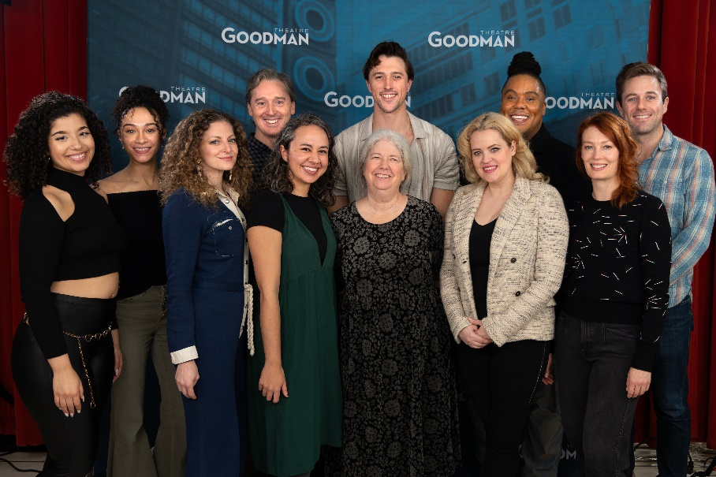
(Chicago, IL) Rehearsals for The Matchbox Magic Flute, Mary Zimmerman’s world-premiere-in-miniature adaptation of Mozart’s magical, family-friendly opera, are underway with a 21-member company of 16 actors and five musicians. Zimmerman celebrates three decades as Goodman Theatre’s Manilow Resident Director directing her theatrical adaptation of the beloved opera, where Prince Tamino (Billy Rude) embarks on a journey to rescue Princess Pamina (Marlene Fernandez)—the daughter of the Queen of the Night (Emily Rohm)—all with the help of a magical flute. Audiences aged 8+ will enjoy the fantastical characters coming to life in this hero’s quest, revealing that things are not always as they seem. A complete cast list appears below. The Matchbox Magic Flute appears February 10 – March 10 (opening night is Monday, February 19 at 7pm). Tickets ($25 - $90; subject to change) are available at GoodmanTheatre.org/Flute or by phone at 312.443.3800. Goodman Theatre is grateful for the support of Mayer Brown, LLP (Corporate Sponsor), PAXXUS Inc. (Contributing Sponsor) and Russell Reynolds Associates (Contributing Sponsor).
“We’re making something that is a bit of old, and a bit of new,” said Mary Zimmerman, the Tony Award-winning adaptor/director whose first Goodman opera was Galileo Galilei with Philip Glass (2002), and who more recently directed Lucia de Lammermoor (Metropolitan Opera, La Scala) and Armida, la Sonnambula, Rusalka (Metropolitan Opera). “Our process relies on the playful, creative collaboration of everyone involved, and I know I will be inspired by this beautiful, eclectic cast of musical theater artists, opera singers and musicians from different genres. I’m extremely excited to get into the room with this bunch of people.”
Playful and imaginative, it’s big music in a small space. This “matchbox” presentation of The Matchbox Magic follows the adventures of Prince Tamino and Princess Pamina. With dragons, a man who is a bird, trials by fire and water and underground corridors, Day and Night do battle in Mary Zimmerman’s brand-new adaptation.

Full Company of The Matchbox Magic Flute (in alphabetical order)
Adapted and Directed by Mary Zimmerman

Marlene Fernandez…..Pamina
Keanon Kyles……Sarastro
Russell Mernagh…..Monostatos
Lauren Molina……Papagena/Lady
Tina Muñoz Pandya……Lady
Reese Parish…….The Spirit
Shawn Pfautsch…...Papageno
Emily Rohm…..Queen of the Night
Billy Rude….Tamino
Monica West…..Lady

Creative Team
Assistant Director….Nora Geffen
Music Adaptor and Arranger…Amanda Dehnert and Andre Pluess
Music Director….Amanda Dehnert
Sound Designer ….Andre Pluess
Associate Music Director/Conductor….Paul Mutzabaugh
Set Designer…..Todd Rosenthal
Costume Designer ……Ana Kuzmanic
Lighting Designer…..T.J. Gerckens
Wig & Hair Designer….Charles “Chuck” LaPointe

Understudies for this production include Dario Amador-Lage (Tamino), Ann Delaney (Papagena/Lady), Devin DeSantis (Papageno/Monostatos), Holly Hinchliffe (Pamina/Spirit), Nathan Karnik (Sarastro) and Emilie Lynn (Queen of the Night/Lady).

Casting is by Lauren Port, CSA. Patrick Fries is the Production Stage Manager and Beth Koehler is the Stage Manager.

ENHANCED AND ACCESSIBLE PERFORMANCES AT GOODMAN THEATRE

Touch Tour* and Audio-Described Performance: Sunday, March 3, 12:30pm Touch Tour; 2pm performance – The action/text is audibly enhanced for patrons via headset.
ASL-Interpreted Performance: Saturday, March 9 at 2pm – Professional ASL interpreter signs the action/text as played.
Spanish-Subtitled Performance: Saturday, March 9 at 7:30pm – An LED sign presents Spanish-translated dialogue in sync with the performance.
Open-Captioned Performance: Sunday, March 10 at 2pm – An LED sign presents dialogue in sync with the performance.
Visit Goodman theatre.org/Access for more information about Goodman Theatre’s accessibility efforts.

ABOUT GOODMAN THEATRE

Chicago’s theater since 1925, Goodman Theatre is a not-for-profit arts and community organization in the heart of the Loop, distinguished by the excellence and scope of its artistic programming and community engagement. Led by Artistic Director Susan V. Booth and Executive Director/CEO Roche Schulfer, the theater’s artistic priorities include new play development (more than 150 world or American premieres), large scale musical theater works and reimagined classics. Artists and productions have earned two Pulitzer Prizes, 22 Tony Awards and more than 160 Jeff Awards, among other accolades.

The Goodman is the first theater in the world to produce all 10 plays in August Wilson’s “American Century Cycle.” Its longtime annual holiday tradition A Christmas Carol, now in its fifth decade, has created a new generation of theatergoers in Chicago. The Goodman also frequently serves as a production and program partner with national and international companies and Chicago’s Off-Loop theaters.

Using the tools of theatrical practice, the Goodman’s Education and Engagement programs aim to develop generations of citizens who understand and empathize with cultures and stories of diverse voices. The Goodman’s Alice Rapoport Center for Education and Engagement is the home of these programs, which are offered for Chicago youth—85% of whom come from underserved communities—schools and life-long learners.

Goodman Theatre was built on the traditional homelands of the Council of the Three Fires: the Ojibwe, Odawa and Potawatomi Nations. We recognize that many other Nations consider the area we now call Chicago as their traditional homeland—including the Myaamia, Ho-Chunk, Menominee, Sac and Fox, Peoria, Kaskaskia, Wea, Kickapoo and Mascouten—and remains home to many Native peoples today. While we believe that our city’s vast diversity should be reflected on the stages of its largest theater, we acknowledge that our efforts have largely overlooked the voices of our Native peoples. This omission has added to the isolation, erasure and harm that Indigenous communities have faced for hundreds of years. We have begun a more deliberate journey towards celebrating Native American stories and welcoming Indigenous communities.

Goodman Theatre was founded by William O. Goodman and his family in honor of their son Kenneth, an important figure in Chicago’s cultural renaissance in the early 1900s. The Goodman family’s legacy lives on through the continued work and dedication of Kenneth’s family, including Albert Ivar Goodman, who with his late mother, Edith-Marie Appleton, contributed the necessary funds for the creation on the new Goodman center in 2000.
Julie Danis is Chair of Goodman Theatre’s Board of Trustees, Lorrayne Weiss is Women’s Board President and Kelli Garcia is President of the Scenemakers Board for young professionals.

—30—

