CONTACT: Denise Schneider and Ata Younan FOR IMMEDIATE RELEASE
312.443.5151 or Press@GoodmanTheatre.org November 6, 2023
IMAGES: Goodman Theatre Press Room

GOODMAN THEATRE’S A CHRISTMAS CAROL CELEBRATES 46 YEARS THIS HOLIDAY SEASON,
STARRING LARRY YANDO AS SCROOGE IN HIS 16TH YEAR AND 10-YEAR-OLD CHRISTIAN LUCAS AS TINY TIM IN HIS GOODMAN DEBUT, DIRECTED BY JESSICA THEBUS, NOVEMBER 18 – DECEMBER 31

***SPECIAL EVENTS AND PERFORMANCES INCLUDE THE ANNUAL GOODMAN TREE LIGHTING (NOVEMBER 26),
A SPANISH-SUBTITLED PERFORMANCE (DECEMBER 17) AND A SENSORY-FRIENDLY PERFORMANCE (DECEMBER 30)***
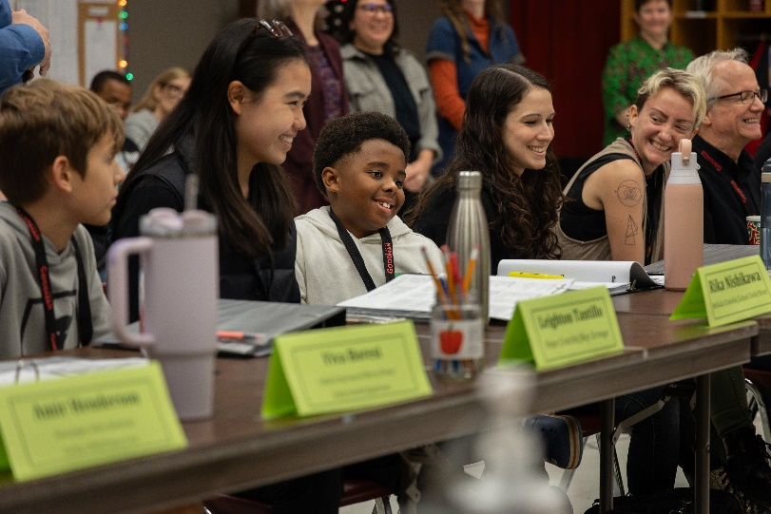
(Chicago, IL) Rehearsals for the 46th annual production of A Christmas Carol, “the greatest seasonal story of all” (Chicago Tribune), are underway. Acclaimed Chicago artist Jessica Thebus returns for her fourth season directing a cast that stars Larry Yando in his 16th year as Ebenezer Scrooge—with Austin Tichenor stepping into the miserly businessman’s shoes for eight performances—leading a cast of 34 newcomers and returning favorites, including Christian Lucas as Tiny Tim joined by young performers Viva Boresi, Annabel Finch, Amir Henderson, Rika Nishikawa and Leighton Tantillo. A complete cast list appears below. A Christmas Carol appears November 18 – December 31 (opening night is Sunday, November 26 at 6:30pm). Tickets ($33 - $159; subject to change) are available at GoodmanTheatre.org/Carol or by phone at 312.443.3800. Visit the website for performance dates when Tichenor will appear as Scrooge. Goodman Theatre is grateful for the support of PNC, Major Corporate Sponsor and Abbott Fund, Corporate Sponsor Partner.

Additionally, the Goodman’s annual Tree Lighting at 6:45pm on opening night, (Sunday, November 26), will feature special guests leading a countdown to light the tree.

“A Christmas Carol is a Chicago tradition, one that I celebrated from the audience as a child, then as a mom and now as an artist,” said Director Jessica Thebus. “This year, we lean into the notion of how we can find each other in celebration, when so much that we encounter in our world seeks to divide us.”

The "perfect Chicago holiday tradition” (Chicago Parent), Dickens’ classic is a “beautiful, timeless message of generosity’s triumph over greed” (Chicago Tribune). Businessman Ebenezer Scrooge’s sizable bank account is only matched by his disdain for the holidays. But one fateful Christmas Eve, Scrooge is visited by four ghosts who take him on a spectacular adventure through his past, present and future, helping him on his discovery of kindness, compassion and redemption in a tale with a “first-rate cast and marvelous staging (that) shines merry and bright" (Chicago Sun-Times). Now in its fifth decade, A Christmas Carol is “still the best Christmas story ever told” (Time Out Chicago) and a signature event of the Chicago holiday season with a star-studded history that includes stage and screen notables like Jessie Mueller, Joe Minoso, Del Close, Harry J. Lennix, Felicia P. Fields, Raul Esparza, Sally Murphy and Frank Galati.

Full Company of A Christmas Carol (in alphabetical order)
By Charles Dickens, Adapted by Tom Creamer, Directed by Jessica Thebus
Adeoye……Ensemble/Poulterer/Stag Deer/Undertaker
Kareem Bandealy………Marley/Young Marley/Topper
Dee Dee Batteast……….Frida
Hillary Bayley…………….Musician
Mark Bedard…………Juggler/Max Fezziwig/Abe/Dilber
Viva Boresi……………Child in Doorway & Mirror/Pratt/Emily Cratchit/Ignorance
Thomas J. Cox…..Bob Cratchit/Wreath Seller
Amira Danan……Belle/Future Crow
Tafadzwa Diener………Martha Cratchit/Fan/Catherine
Jalbelly Guzmán…….…Dance Captain/Ensemble/Hat Seller/Doe Deer/Young Woman
Amir Henderson….……Newspaper Seller/Johnston/Gregory Cratchit/Turkey Child/Future Crow
Gregory Hirte…………Musician/Dick Wilkins/Young Man
Susaan Jamshidi……Mrs. Cratchit
Christian Lucas………Tiny Tim/School Child
Daniel José Molina……Young Scrooge/Ghost of Christmas Future
Rika Nishikawa…………Belinda Cratchit/School Child
Detra Payne…………..…Chestnut Seller/Philomena/Old Josephine
Delin Ruhl……………Musician
Malcolm Ruhl………Musician
Robert Schleifer……Mr. Fezziwig
Lucky Stiff………Ghost of Christmas Past
Leighton Tantillo……Peter Cratchit/Boy Scrooge/Want
Bethany Thomas………Charwoman/Ghost of Christmas Present
Austin Tichenor………Alternate Ebenezer Scrooge
Penelope Walker……Crumb/Mrs. Alice Fezziwig
Andrew White…………Narrator
Larry Yando………Ebenezer Scrooge
Wai Yim……Ortle/Tree Seller/School Official
Jazzlyn Luckett Aderele……US Crumb/Charwoman/Doe Deer/Mrs. Alice Fezziwig
Tatiana Bustamante……….US Ghost of Christmas Past/Martha/Fan/Belle/Young Woman
Arash Fakhrabadi….……….US Young Man/Poulterer/Dick Wilkins/Abe/Undertaker/Old Joe
Annabel Finch……….US Young Performers
Sam Hyson…….………US Musician
Loren Jones….………US Bob Cratchit/Narrator/Ortle/Marley/Young Marley
Creative Team

Assistant Director….Jamal Howard
Set Designer…..Todd Rosenthal
Costume Designer ……Heidi Sue McMath
Puppet Designers & Creators….Jillian Gryzlak and Rachel Anne Healy
Lighting Designer…..Keith Parham
Associate Lighting Designer…Brian Elston
Sound Designers…..Richard Woodbury and Pornchanok Kanchanabanca
Composer….Andrew Hansen
Music Director…..Malcolm Ruhl
Choreographer….Tommy Rapley
Fly Director….Andrea Gentry

Casting is by Lauren Port, CSA and Rachael Jimenez, CSA. Neena Arndt is the Dramaturg. Kimberly Ann McCann is the Production Stage Manager and Jennifer Gregory and Beth Koehler are the Stage Managers. Flying effects are provided by ZFX Inc.

ENHANCED AND ACCESSIBLE PERFORMANCES AT GOODMAN THEATRE

Touch Tour* and Audio-Described Performance: Saturday, December 9, 12:30pm Touch Tour; 2pm performance – The action/text is audibly enhanced for patrons via headset.
ASL-Interpreted Performance: Friday, December 15 at 7:30pm – Professional ASL interpreter signs the action/text as played.
Open-Captioned Performance: Sunday, December 17 at 2pm – An LED sign presents dialogue in sync with the performance.
Spanish-Subtitled Performance: Sunday, December 17 at 7pm – An LED sign presents Spanish-translated dialogue in sync with the performance.
Sensory-Friendly Performance: Saturday, December 30 at 2pm – Sensory-friendly/relaxed performances are designed to create a performing arts experience that is intended for patrons who have autism or other social, cognitive and physical challenges that create sensory sensitivities and their families.
Visit Goodman theatre.org/Access for more information about Goodman Theatre’s accessibility efforts.

ABOUT GOODMAN THEATRE

Chicago’s theater since 1925, Goodman Theatre is a not-for-profit arts and community organization in the heart of the Loop, distinguished by the excellence and scope of its artistic programming and community engagement. Led by Artistic Director Susan V. Booth and Executive Director/CEO Roche Schulfer, the theater’s artistic priorities include new play development (more than 150 world or American premieres), large scale musical theater works and reimagined classics. Artists and productions have earned two Pulitzer Prizes, 22 Tony Awards and more than 160 Jeff Awards, among other accolades.

The Goodman is the first theater in the world to produce all 10 plays in August Wilson’s “American Century Cycle.” Its longtime annual holiday tradition A Christmas Carol, now in its fifth decade, has created a new generation of theatergoers in Chicago. The Goodman also frequently serves as a production and program partner with national and international companies and Chicago’s Off-Loop theaters.

Using the tools of theatrical practice, the Goodman’s Education and Engagement programs aim to develop generations of citizens who understand and empathize with cultures and stories of diverse voices. The Goodman’s Alice Rapoport Center for Education and Engagement is the home of these programs, which are offered for Chicago youth—85% of whom come from underserved communities—schools and life-long learners.

Goodman Theatre was built on the traditional homelands of the Council of the Three Fires: the Ojibwe, Odawa and Potawatomi Nations. We recognize that many other Nations consider the area we now call Chicago as their traditional homeland—including the Myaamia, Ho-Chunk, Menominee, Sac and Fox, Peoria, Kaskaskia, Wea, Kickapoo and Mascouten—and remains home to many Native peoples today. While we believe that our city’s vast diversity should be reflected on the stages of its largest theater, we acknowledge that our efforts have largely overlooked the voices of our Native peoples. This omission has added to the isolation, erasure and harm that Indigenous communities have faced for hundreds of years. We have begun a more deliberate journey towards celebrating Native American stories and welcoming Indigenous communities.

Goodman Theatre was founded by William O. Goodman and his family in honor of their son Kenneth, an important figure in Chicago’s cultural renaissance in the early 1900s. The Goodman family’s legacy lives on through the continued work and dedication of Kenneth’s family, including Albert Ivar Goodman, who with his late mother, Edith-Marie Appleton, contributed the necessary funds for the creation on the new Goodman center in 2000.
Julie Danis is Chair of Goodman Theatre’s Board of Trustees, Lorrayne Weiss is Women’s Board President and Kelli Garcia is President of the Scenemakers Board for young professionals.

—30—

