CONTACT: Denise Schneider and Ata Younan FOR IMMEDIATE RELEASE
312.443.5151 or Press@GoodmanTheatre.org October 2, 2023

THE NACIREMA SOCIETY EXTENDS WITH FIVE PERFORMANCES ADDED, THROUGH OCTOBER 22;
LUCHA TEOTL BEGINS PERFORMANCES, WELCOMES AUDIENCES TO THE RING;
THE MAGIC PARLOUR OPENS ITS DOORS ON OCTOBER 5

***SUSAN V. BOOTH’S FIRST CURATED SEASON AS GOODMAN ARTISTIC DIRECTOR IS IN FULL SWING***

(Chicago, IL) Goodman Theatre’s 2023/2024 Season—the first that Susan V. Booth has curated as new Artistic Director—is fully underway with plays on both stages, a citywide celebration plus opening a new performance venue. On the heels of a critically acclaimed opening night, the Goodman extends Lili-Anne Brown’s Chicago-premiere production of Pearl Cleage’s The Nacirema Society Requests the Honor of Your Presence at a Celebration of Their First One Hundred Years in the Albert Theatre (see performance schedule below). Next door, in the Owen Theatre, the luchadores of LUCHA TEOTL, by Christopher Llewyn Ramirez and Jeff Colangelo, have begun preview performances (opening night is October 9) while magician Dennis Watkins prepares to open the doors to the all-new The Magic Parlour at 50 W. Randolph on October 5, in partnership with the Goodman and Petterino’s. Tickets to all three productions are now available at GoodmanTheatre.org or by phone at 312.443.3800.
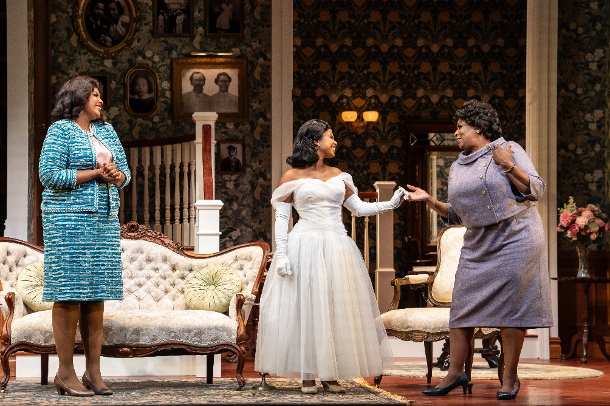
The Nacirema Society extension week performances include Thursday, October 19 at 7:30pm; Friday, October 20 at 2pm; Saturday, October 21 at 2pm and 7:30pm; and Sunday, October 22 at 2pm. Lili-Anne Brown directs the Chicago premiere and centerpiece production of the citywide Pearl Cleage Festival. It’s 1964 Montgomery, Alabama, and the Nacirema Society prepares for its annual introduction of six elegant African-American debutantes to a world of prosperity, privilege and social responsibility. This centennial year, the Society’s grande dame, Grace Dunbar, will have nothing less than perfection for her granddaughter Gracie’s debut. And with young love brewing, old family skeletons rattling, national media attention abounding and a blackmail plot bubbling…what would dare go awry? The Goodman is grateful for the support of JP Morgan Chase & Co. (Lead Corporate Sponsor) and Allstate (Major Corporate Sponsor). The Nacirema Society appears through October 22 in the 856-seat Albert Theatre. Tickets ($35 –$90, subject to change) are available at GoodmanTheatre.org/Society or by phone at 312-443-3800. The Pearl Cleage Festival continues, honoring the prolific playwright’s distinguished career, which spans 40 years and more than 30 plays, novels, poems and essays. The festival, conceived by Booth, curated by Goodman Theatre BOLD Artistic Producer Malkia Stampley and produced in partnership with Chicago’s famed Off-Loop companies, features 10 events through October 15.

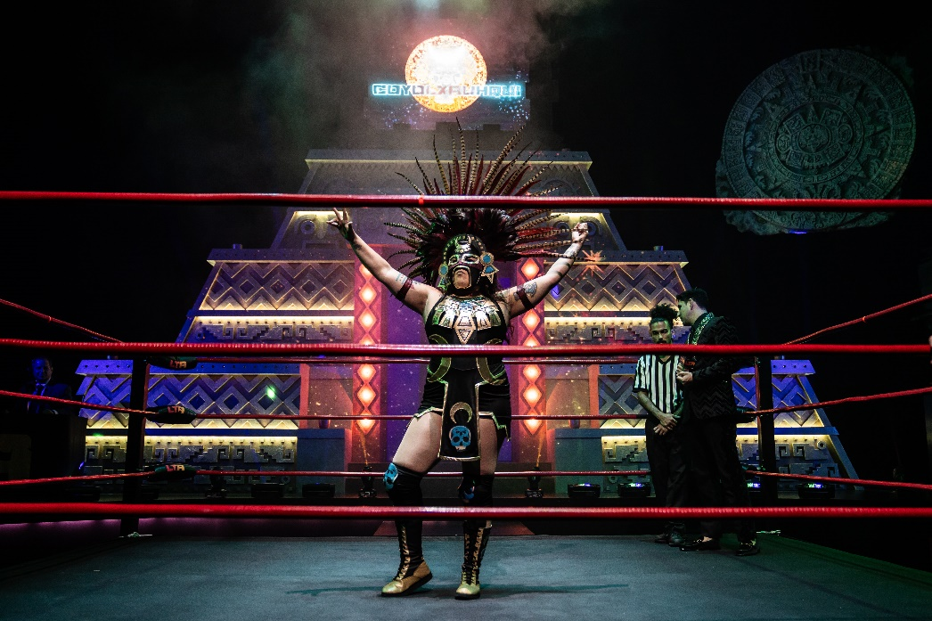
In LUCHA TEOTL, will the forces of light prevail over darkness? Masked luchadores representing Aztec gods vie for domination in this no-holds-barred, 90-minute thrill ride about family, honor, tradition and redemption, written and directed by Christopher Llewyn Ramirez and Jeff Colangelo. A full-sized professional wrestling ring and a 15-foot-high Aztec calendar set the stage for the heart-pumping action, transforming the Goodman’s 350-seat flexible Owen Theatre into an immersive space that encourages audience participation. Conceived by Prism Movement Theatre and produced in partnership with Chicago Latino Theater Alliance (CLATA) as part of the 2023 Destinos Festival. The Goodman is grateful for the support Bank of America (Contributing Sponsor) and The Elizabeth Morse Charitable Trust (Lead Funder of IDEAA Programming). LUCHA TEOTL appears through October 29, 2023 in the 350-seat Owen Theatre; opening night is Monday, October 9. Tickets ($25 –$70, subject to change) are available at GoodmanTheatre.org/Lucha or by phone at 312-443-3800.
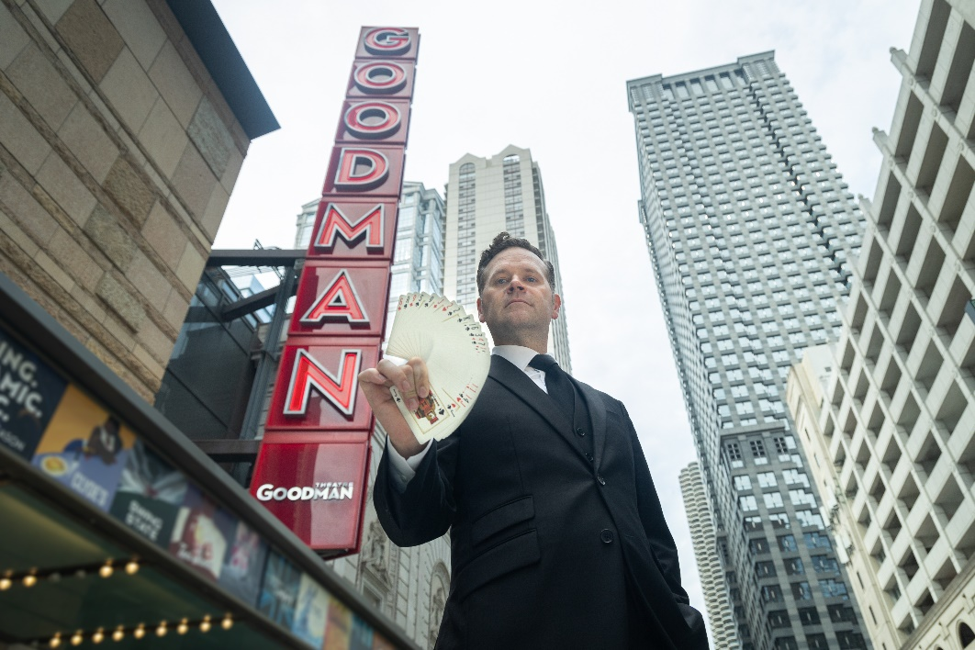
The Magic Parlour becomes Chicago’s first venue dedicated solely to close-up magic this week when the first audiences visit the brand-new performance space at 50 W. Randolph—established in an unprecedented partnership with the Goodman and Petterino’s. Hailed as “Chicago’s magic man” (Chicago Sun-Times), Dennis Watkins, the award-winning third-generation magician and mind-reader behind Chicago’s longest running magic show, builds on his 15-year success, most recently at the Palmer House. Beginning October 5, six weekly performances take place on Thursday (7:30pm); Friday (7pm and 9:30pm); Saturday (4:30pm and 7:30pm); and Sunday (2pm). Tickets are $95 for the performance or $125 for the performance + Encore Room (a VIP 25-minute up-close magic experience following the performance for up to 20 guests in private space). All tickets include a complimentary beverage. Call the Box Office, 312.443.3800 (12 Noon – 5pm daily) or visit TheMagicParlourChicago.com. Media dates are Oct. 26-29; invitations will be issued soon (press only).

ABOUT GOODMAN THEATRE

Chicago’s theater since 1925, Goodman Theatre is a not-for-profit arts and community organization in the heart of the Loop, distinguished by the excellence and scope of its artistic programming and community engagement. Led by Artistic Director Susan V. Booth and Executive Director/CEO Roche Schulfer, the theater’s artistic priorities include new play development (more than 150 world or American premieres), large scale musical theater works and reimagined classics. Artists and productions have earned two Pulitzer Prizes, 22 Tony Awards and more than 160 Jeff Awards, among other accolades. The Goodman is the first theater in the world to produce all 10 plays in August Wilson’s “American Century Cycle.” Its longtime annual holiday tradition A Christmas Carol, now in its fifth decade, has created a new generation of theatergoers in Chicago. The Goodman also frequently serves as a production and program partner with national and international companies and Chicago’s Off-Loop theaters.

Using the tools of theatrical practice, the Goodman’s Education and Engagement programs aim to develop generations of citizens who understand and empathize with cultures and stories of diverse voices. The Goodman’s Alice Rapoport Center for Education and Engagement is the home of these programs, which are offered for Chicago youth—85% of whom come from underserved communities—schools and life-long learners.

Goodman Theatre was built on the traditional homelands of the Council of the Three Fires: the Ojibwe, Odawa and Potawatomi Nations. We recognize that many other Nations consider the area we now call Chicago as their traditional homeland—including the Myaamia, Ho-Chunk, Menominee, Sac and Fox, Peoria, Kaskaskia, Wea, Kickapoo and Mascouten—and remains home to many Native peoples today. While we believe that our city’s vast diversity should be reflected on the stages of its largest theater, we acknowledge that our efforts have largely overlooked the voices of our Native peoples. This omission has added to the isolation, erasure and harm that Indigenous communities have faced for hundreds of years. We have begun a more deliberate journey towards celebrating Native American stories and welcoming Indigenous communities.

Goodman Theatre was founded by William O. Goodman and his family in honor of their son Kenneth, an important figure in Chicago’s cultural renaissance in the early 1900s. The Goodman family’s legacy lives on through the continued work and dedication of Kenneth’s family, including Albert Ivar Goodman, who with his late mother, Edith-Marie Appleton, contributed the necessary funds for the creation on the new Goodman center in 2000. Julie Danis is Chair
of Goodman Theatre’s Board of Trustees, Lorrayne Weiss is Women’s Board President and Kelli Garcia is President of the Scenemakers Board for young professionals.

—30—

