CONTACT: Denise Schneider and Ata Younan FOR IMMEDIATE RELEASE
312.443.5151 or Press@GoodmanTheatre.org October 18, 2023

FIVE ADDITIONAL PERFORMANCES OF SMASH SENSATION LUCHA TEOTL—A “RIP-ROARING GOOD TIME” (SPLASH)—EXTEND THE CHICAGO-PREMIERE PRODUCTION THROUGH NOVEMBER 5

***SPECIAL EVENTS INCLUDE “MUCHA LUCHA” LUCHADOR MASK CONTEST (OCTOBER 21) AND
A TEQUILA-TASTING AND LUCHADOR CRASH COURSE (OCTOBER 28)***

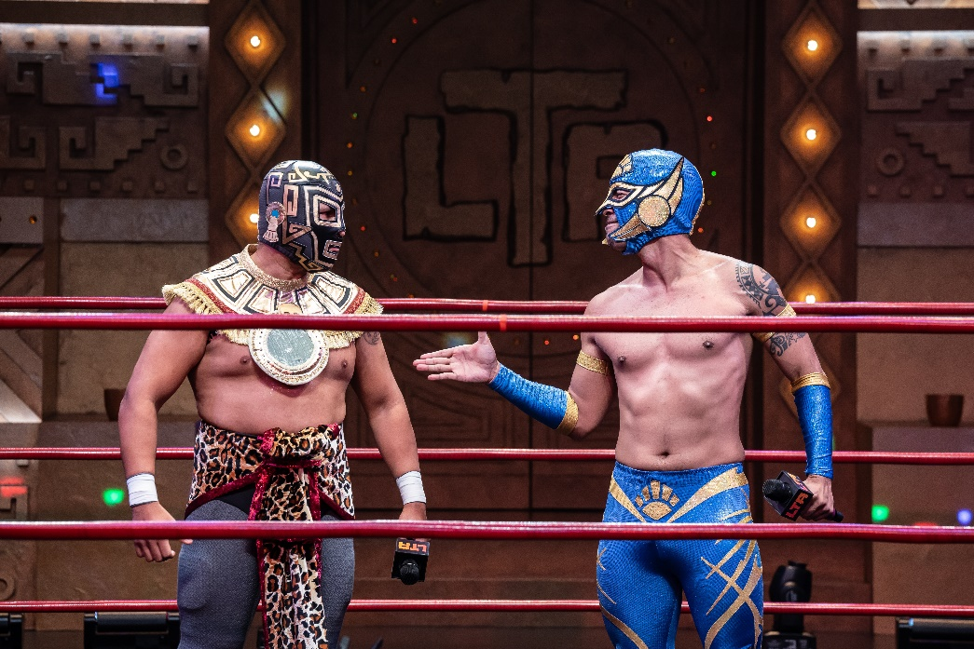
(Chicago, IL) The forces of light and dark vie for domination for another week—with five added performances of the “irresistible” (Chicago Sun-Times) LUCHA TEOTL. The critically acclaimed immersive play rooted in Aztec mythology brings masked luchadores to the wrestling ring in a story about family, honor, tradition and redemption. LUCHA TEOTL extension week performances include November 2 at 7:30pm; November 3 at 7:30pm; November 4 at 2pm and 7:30pm; and November 5 at 2pm. Written and directed by co-creators Christopher Llewyn Ramirez and Jeff Colangelo and produced in partnership with the National Museum of Mexican Art and Chicago Latino Theater Alliance (CLATA) as part of the 2023 Destinos Festival, LUCHA TEOTL appears through November 5, 2023 in the 350-seat Owen Theatre. Tickets ($25 –$60, subject to change) are available at GoodmanTheatre.org/Lucha or by phone at 312-443-3800. The Goodman is grateful for the support Bank of America (Contributing Sponsor) and The Elizabeth Morse Charitable Trust (Lead Funder of IDEAA Programming).

Upcoming special events around the production include MUCHA LUCHA (October 21 at 7:30pm) inviting audiences to dress as a favorite luchador or wrestler for chance to win LUCHA TEOTL merchandise and enjoy a custom photobooth by GlitterGuts. In addition, professional wrestlers and cast members Luis “Aski” Palomino and Paloma “Starr” Varga give a behind-the-scenes look at Lucha Libre—while guests sample Ghost Tequila and more from Republic National Distributing—at the LUCHA TEOTL 101 and Tequila Tasting reception (October 28 at 6pm). The event includes appetizers along with a raffle for a chance to take home tequilas from Rancho La Gloria and Lethal.

ABOUT GOODMAN THEATRE

Chicago’s theater since 1925, Goodman Theatre is a not-for-profit arts and community organization in the heart of the Loop, distinguished by the excellence and scope of its artistic programming and community engagement. Led by Artistic Director Susan V. Booth and Executive Director/CEO Roche Schulfer, the theater’s artistic priorities include new play development (more than 150 world or American premieres), large scale musical theater works and reimagined classics. Artists and productions have earned two Pulitzer Prizes, 22 Tony Awards and more than 160 Jeff Awards, among other accolades. The Goodman is the first theater in the world to produce all 10 plays in August Wilson’s “American Century Cycle.” Its longtime annual holiday tradition A Christmas Carol, now in its fifth decade, has created a new generation of theatergoers in Chicago. The Goodman also frequently serves as a production and program partner with national and international companies and Chicago’s Off-Loop theaters.

Using the tools of theatrical practice, the Goodman’s Education and Engagement programs aim to develop generations of citizens who understand and empathize with cultures and stories of diverse voices. The Goodman’s Alice Rapoport Center for Education and Engagement is the home of these programs, which are offered for Chicago youth—85% of whom come from underserved communities—schools and life-long learners.

Goodman Theatre was built on the traditional homelands of the Council of the Three Fires: the Ojibwe, Odawa and Potawatomi Nations. We recognize that many other Nations consider the area we now call Chicago as their traditional homeland—including the Myaamia, Ho-Chunk, Menominee, Sac and Fox, Peoria, Kaskaskia, Wea, Kickapoo and Mascouten—and remains home to many Native peoples today. While we believe that our city’s vast diversity should be reflected on the stages of its largest theater, we acknowledge that our efforts have largely overlooked the voices of our Native peoples. This omission has added to the isolation, erasure and harm that Indigenous communities have faced for hundreds of years. We have begun a more deliberate journey towards celebrating Native American stories and welcoming Indigenous communities.

Goodman Theatre was founded by William O. Goodman and his family in honor of their son Kenneth, an important figure in Chicago’s cultural renaissance in the early 1900s. The Goodman family’s legacy lives on through the continued work and dedication of Kenneth’s family, including Albert Ivar Goodman, who with his late mother, Edith-Marie Appleton, contributed the necessary funds for the creation on the new Goodman center in 2000. Julie Danis is Chair
of Goodman Theatre’s Board of Trustees, Lorrayne Weiss is Women’s Board President and Kelli Garcia is President of the Scenemakers Board for young professionals.
—30—

