CONTACT: Denise Schneider and Ata Younan FOR IMMEDIATE RELEASE
312.443.5151 or Press@GoodmanTheatre.org August 14, 2023
IMAGES: Goodman Press Room

THE WHO’S TOMMY IS THE MOST SUCCESSFUL PRODUCTION IN GOODMAN THEATRE HISTORY

**TWICE-EXTENDED AND SOLD-OUT, THE EIGHT-WEEK RUN SMASHED SALES RECORDS, DREW AUDIENCES
FROM ALL 50 STATES, PUERTO RICO AND WASHINGTON, D.C. AND 21 COUNTRIES AROUND THE GLOBE**

***EXCLUSIVE VIDEO: TONY AWARD-WINNING ORIGINAL CREATORS PETE TOWNSHEND AND DES McANUFF
JOIN THE COMPANY ON STAGE FOR A BOW AS THE ‘AMAZING JOURNEY’ CONCLUDES IN CHICAGO***

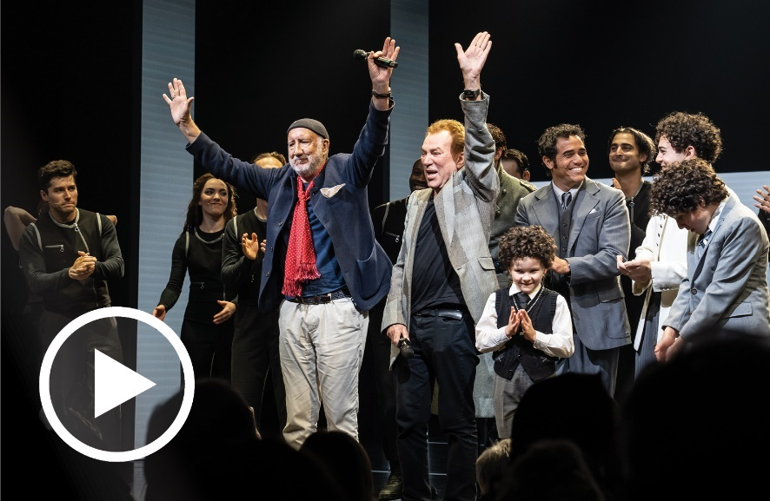
(Chicago, IL) Artistic Director Susan V. Booth and Executive Director/CEO Roche Schulfer announced today that the Goodman’s must-see musical The Who’s Tommy smashed box office records, officially becoming the highest-grossing production in the 98-year history of Chicago’s largest not-for-profit theater company. The unanimously acclaimed, twice-extended production “went clean” in the 856-seat Albert Theatre selling a record number of single tickets and selling out 36 performances. Audiences attending hailed from all 50 United States, including the District of Columbia and Puerto Rico, as well as 21 other countries as far away as New Zealand, with many patrons attending multiple performances. Based on The Who’s original 1969 rock opera, The Who’s Tommy is the story of Tommy Walker reimagined for 2023 by its original Tony Award winning co-creators—music and lyrics by Pete Townshend and book by Townshend and Des McAnuff, who also directs—featuring a cast of 29 accompanied by a nine-piece orchestra. On closing weekend (August 5 and 6), the original Tony Award-winning creators brought the sold-out, standing-room-only crowd to their feet when they joined the company on stage for curtain call and bow.

In a joint statement, Artistic Director Susan V. Booth and Executive Director/CEO Roche Schulfer said, “The Who’s Tommy at the Goodman is, to borrow a phrase, a ‘sensation’—an aural and visual feast of the fullest imagination, a production of the highest quality and an unprecedented technical achievement that will remain indelibly with all who experienced it for years to come. We are most grateful to Des McAnuff and Pete Townshend, along with our cast, musicians, creative team and crew for their enormous talent and hard work on stage, and behind the scenes, every night. We thank our sponsors, Northern Trust (Lead Corporate Sponsor), Winston & Strawn LLP (Major Corporate Sponsor) and Shure (Technical Supporter). And sincerely thank our audience for being part of this ‘amazing journey’—and for supporting Chicago theater as we continue to rebound following the pandemic shut-down.”

Myth and spectacle combine in this 2023 reimagining of The Who’s 1969 rock concept album, Tommy—including the unforgettable anthems “I’m Free,” “See Me, Feel Me,” “Sensation” and “Pinball Wizard.” After witnessing his father shoot his rival, the young Tommy Walker is lost in the universe, endlessly and obsessively staring into the mirror. An innate knack for pinball catapults him from reticent adolescent to celebrity savior.

A cast of 29 and a nine-piece band performs the classic songs in an exciting new staging. In title role of Tommy Walker is Ali Louis Bourzgui (Layalina, The Band’s Visit national tour), with Adam Jacobs (Aladdin, Les Misérables and The Lion King on Broadway) as his father, Captain Walker and Alison Luff (Escape to Margaritaville, Waitress and Matilda on Broadway) as his mother, Mrs. Walker. The cast also includes John Ambrosino (Les Misérables on Broadway) as Uncle Ernie; Bobby Conte (Company, A Bronx Tale The Musical on Broadway) as Cousin Kevin; and Christina Sajous (SpongeBob SquarePants and Holler If Ya Hear Me on Broadway) as the Acid Queen.

The cast also includes Jeremiah Alsop, Stephen Brower, Haley Gustafson, Sheldon Henry, Aliah James, Gabriel Kearns, Tassy Kirbas Lily Kren, Nathan Lucrezio, Alexandra Matteo, Morgan McGhee, Mark Mitrano, Reagan Pender, Daniel Quadrino, Nathe Rowbotham, Jenna Nicole Schoen, Zach Sorrow, Ayana Strutz and Andrew Tufano. Young Tommy is played as a child and a pre-adolescent by the following actors in rotation: Ava Rose Doty, Presley Rose Jones, Annabel Finch and Ezekiel Ruiz.

The creative team includes choreography by Lorin Latarro (Into the Woods, Mrs. Doubtfire and Waitress on Broadway); music supervision and additional arrangements by Ron Melrose (Jersey Boys on Broadway, London and national tour); set design by David Korins (Hamilton, Beetlejuice, Here Lies Love on Broadway); costume design by Sarafina Bush (for colored girls..., Pass Over on Broadway); lighting design by Amanda Zieve (Broadway associate on Escape to Margaritaville and Allegiance); sound design by Gareth Owen (Back to the Future, & Juliet and MJ The Musical on Broadway); and projection design by Peter Nigrini (MJ: The Musical and Dear Evan Hansen on Broadway). Casting is by Lauren Port, CSA and Rachael Jimenez, CSA. New York casting by Tara Rubin Casting/Merri Sugarman, CSA. Tripp Phillips is the Production Stage Manager and Nikki Blue and Jason Hindelang are the Stage Managers.

A nine-piece band performs the Tony Award-winning original score, featuring Rick Fox (Keyboard/Conductor), Valerie Gebert (Keyboard/Associate Conductor), Bobby Everson (Percussion), Chris Forte (Guitar), Jeremiah Frederick (Horn), Larry Kohut (Bass), Felton Offard (Guitar), Rose Snyder (Keyboard) and Jim Widlowski (Drums).

ABOUT THE CREATORS

Pete Townshend is known principally as the lead guitarist and composer for The Who, as well as for his own solo career. His career with The Who spans over fifty years, during which time Townshend wrote well over a hundred songs for The Who’s eleven studio albums, including the rock operas Tommy and Quadrophenia and the well-regarded rock radio staple Who’s Next. From early classic singles, such as ‘My Generation’ and ‘Substitute’ to ‘Tommy’, ‘Lifehouse’ and ‘Quadrophenia’, Townshend has always been at the forefront of his profession. Though known mainly as a guitarist, he is an accomplished singer and keyboard player, and has played many other instruments (banjo, accordion, synthesizer, piano, bass guitar and drums) on his solo albums and on certain Who albums. As an author, he has written Horse’s Neck, a collection of short stories (Faber & Faber, 1985); Who I Am, a memoir (Harper Collins, 2012) and his latest artistic project, The Age of Anxiety, is simultaneously a novel and a rock opera about passion and ambition, good drugs and bad drugs, and loves lost and found (the novel was published by Hodder & Stoughton, 2019). His numerous awards for The Who’s Tommy include a Grammy Award (1993), Tony Award for Best score (1993), Dora Mavor Moore Award (1994) and Olivier Award (1997). Other awards include Classic Rock Award (2011); Ivor Novello Award (1981); British Phonographic Industry Lifetime Achievement Award (1983); BRIT Award for contribution to British Music (1988); Living Legend Award, International Rock Awards (1991); Q Lifetime Achievement Award (1997); Ivor Novello Lifetime Achievement Award (2001); Kennedy Center Honor, John F. Kennedy Center for Performing Arts (jointly with Roger Daltrey, 2008); Rock Honor, VH1 (2008); Honorary Doctorate West London University (2010); Les Paul Award, TEC Foundation (2012). The most recent Who album, WHO, was released on December 6, 2019.

Des McAnuff is a two-time Tony Award-winning director and former artistic director of Canada’s Stratford Festival. He is also director emeritus of La Jolla Playhouse, where he staged over 30 productions of classics, new plays and musicals as artistic director. He’s co-founder of Broadway’s Dodgers. Broadway credits include Ain’t Too Proud: The Life and Times of the Temptations; Summer: The Donna Summer Musical; Doctor Zhivago; Jesus Christ Superstar; Guys and Dolls; Aaron Sorkin’s The Farnsworth Invention; Jersey Boys (Tony and Olivier awards: Best Musical); Billy Crystal’s 700 Sundays (Tony Award: Best Special Theatrical Event); Dracula the Musical; How to Succeed…; The Who’ s Tommy (Tony and Olivier awards: Best Director); A Walk in the Woods and Big River (Tony awards: Best Director, Best Musical). Selected New York credits include Fetch Clay, Make Man (NYTW); multiple productions at The Public and BAM. Stratford highlights include: A Word or Two; Caesar and Cleopatra and The Tempest (all with Christopher Plummer). Opera credits include Faust (The Met, ENO). TV and film credits include 700 Sundays (HBO); Cousin Bette (with Jessica Lange, director); The Iron Giant (producer, BAFTA Award) and Quills (executive producer). In 2011, he was honored with a doctorate from Ryerson University where he attended theater school. In 2012, he was awarded Canada’s Governor General’ s National Arts Center Award and the Order of Canada.

THE COMPANY OF THE WHO’S TOMMY
For images, bios and additional information about the artists, visit the Play Detail Page.
(listed in alphabetical order)

Male Ensemble/Lad 2…Jeremiah Alsop
Uncle Ernie…John Ambrosino
Tommy/Narrator….Ali Louis Bourzgui
Male Ensemble/Minister…Stephen Brower
Cousin Kevin…Bobby Conte
Tommy, Age 4….Ava Rose Doty
Tommy, Age 10…Annabel Finch
Female Ensemble/Sally Simpson…Haley Gustafson
Male Ensemble/Hawker/Specialist…Sheldon Henry
Captain Walker…Adam Jacobs
Female Ensemble…Aliah James
Tommy, Age 4…Presley Rose Jones
Male Ensemble…Gabriel Kearns
Onstage Swing…Tassy Kirbas
Female Ensemble…Lily Kren
Male Ensemble…Nathan Lucrezio*
Mrs. Walker…Alison Luff
Female Ensemble…Alexandra Matteo
Female Ensemble…Morgan McGhee
Male Ensemble/Lad 1…Mark Mitrano
Onstage Swing…Reagan Pender
Male Ensemble…Daniel Quadrino
Tommy, Age 10…Ezekiel Ruiz
Acid Queen/Specialist’s Assistant…Christina Sajous
Female Ensemble…Jenna Nicole Schoen
Onstage Swing…Zach Sorrow
Offstage Female Swing…Ayana Strutz
Onstage Swing…Andrew Tufano

*Denotes Dance Captain

Choreography…Lorin Latarro
Set Design…David Korins
Costume Design…Sarafina Bush
Lighting Design…Amanda Zieve
Sound Design…Gareth Owen
Projection Design…Peter Nigrini
Flying Effects…ZFX Inc.

Music Supervision and Additional Arrangements…Ron Melrose
Music Director/Conductor/Keyboard 2…Rick Fox
Associate Conductor/Keyboard 3…Valerie Gebert
Keyboard 1…Rose Snyder
French Horn…Jeremiah Frederick
Guitar 1…Chris Forte
Guitar 2…Felton Offard
Bass…Larry Kohut
Percussion…Bobby Everson
Drums…Jim Widlowski

Casting is by Lauren Port, CSA and Rachael Jimenez, CSA. New York casting by Tara Rubin Casting/Merri Sugarman, CSA. Tripp Phillips is the Production Stage Manager; Jason Hindelang and Nikki Blue are Stage Managers.

ENHANCED AND ACCESSIBLE PERFORMANCES
Visit Goodman theatre.org/Access for more information about Goodman Theatre’s accessibility efforts.

-ASL-Interpreted: Friday, July 7 at 8pm – An American Sign Language interpreter signs the action/text as played.
-Touch Tour (12:30pm) and Audio-Described Performance (2pm): Saturday, July 15
-Spanish Subtitles: Saturday, July 15 at 8pm
-Open-Captioned: Sunday, July 16 at 2pm – An LED sign presents dialogue in sync with the performance.

ABOUT GOODMAN THEATRE

Chicago’s theater since 1925, Goodman Theatre is a not-for-profit arts and community organization in the heart of the Loop, distinguished by the excellence and scope of its artistic programming and community engagement. Led by Artistic Director Susan V. Booth and Executive Director/CEO Roche Schulfer, the theater’s artistic priorities include new play development (more than 150 world or American premieres), large scale musical theater works and reimagined classics. Artists and productions have earned two Pulitzer Prizes, 22 Tony Awards and more than 160 Jeff Awards, among other accolades.

The Goodman is the first theater in the world to produce all 10 plays in August Wilson’s “American Century Cycle.” Its longtime annual holiday tradition A Christmas Carol, now in its fifth decade, has created a new generation of theatergoers in Chicago. The Goodman also frequently serves as a production and program partner with national and international companies and Chicago’s Off-Loop theaters.

Using the tools of theatrical practice, the Goodman’s Education and Engagement programs aim to develop generations of citizens who understand and empathize with cultures and stories of diverse voices. The Goodman’s Alice Rapoport Center for Education and Engagement is the home of these programs, which are offered for Chicago youth—85% of whom come from underserved communities—schools and life-long learners.

Goodman Theatre was built on the traditional homelands of the Council of the Three Fires: the Ojibwe, Odawa and Potawatomi Nations. We recognize that many other Nations consider the area we now call Chicago as their traditional homeland—including the Myaamia, Ho-Chunk, Menominee, Sac and Fox, Peoria, Kaskaskia, Wea, Kickapoo and Mascouten—and remains home to many Native peoples today. While we believe that our city’s vast diversity should be reflected on the stages of its largest theater, we acknowledge that our efforts have largely overlooked the voices of our Native peoples. This omission has added to the isolation, erasure and harm that Indigenous communities have faced for hundreds of years. We have begun a more deliberate journey towards celebrating Native American stories and welcoming Indigenous communities.

Goodman Theatre was founded by William O. Goodman and his family in honor of their son Kenneth, an important figure in Chicago’s cultural renaissance in the early 1900s. The Goodman family’s legacy lives on through the continued work and dedication of Kenneth’s family, including Albert Ivar Goodman, who with his late mother, Edith-Marie Appleton, contributed the necessary funds for the creation on the new Goodman center in 2000.
Jeff Hesse is Chairman of Goodman Theatre’s Board of Trustees, Fran Del Boca is Women’s Board President and Craig McCaw is President of the Scenemakers Board for young professionals.

—30—

